Myrrh (Haydel) Poche
January 7, 1933 – December 10, 2021

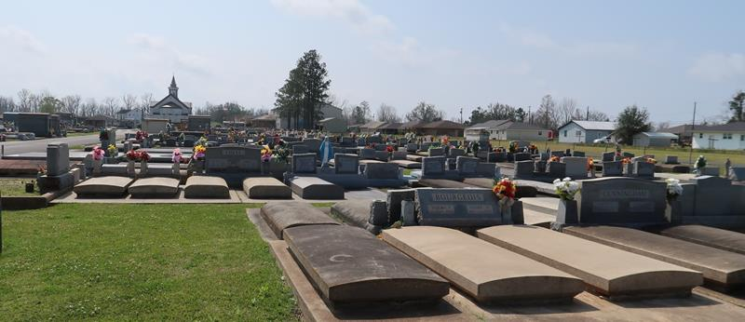

Myrrh Haydel Poche’ died peacefully at her home December 10, 2021 after a prolonged battle with multiple myeloma. She was born January 7, 1933 and was 88 years old. She devoted her entire life to God, her family, and her many, many friends. She befriended everyone she met. She was a very devoted Catholic, a committed adorer at Our Lady of Prompt Succor Adoration Chapel, a member of Saint Joseph choir, the Catholic Daughters, and volunteered her precious time to help Father Albert Hebert with distributing his many Catholic books about the Blessed Mother.
She was a lady of many talents including: playing the piano, needlepoint, multiple crafts, gardening, and she was a self-taught chef who was not afraid to cook any meal. She is remembered especially by her uncanny knack to help others who were in need or in trouble.
She is survived by her high school sweetheart husband of 68 1/2 years, Dr. Carl Poche’, her six children: Paula Forsythe (Larry), Dr. Randall (Pam), Brenda (Tipsy Marie grand dog), Dr. Jerry (Tessa), Enid Smith (Tom), and Susan Hawthorne (Chuck), and one granddaughter, 12 grandsons, and 18 great grandchildren, and a sister, Joyce Bedell.
She is preceded in death by her parents, Henry and Enid Haydel, sisters Melba East and little Irma, brother Ray Haydel, and great granddaughter infant, Lily Joy Hines. The family wants to give a special thanks to her devoted caregivers, Paula Adams and Pamela Leblanc, who provided gentle and loving care to her.
A visitation will be held at St. Joseph Catholic Church on Tuesday, December 14, 2021 from 10:30 AM until the funeral time. A Mass of Christian Burial will take place at 1:00 PM. Interment will follow in Saint Joseph’s Cemetery.

Rose Lynn Funeral Services, Lutcher, Louisiana

