Malcolm Roberts
November 25, 1949 - March 7, 2026

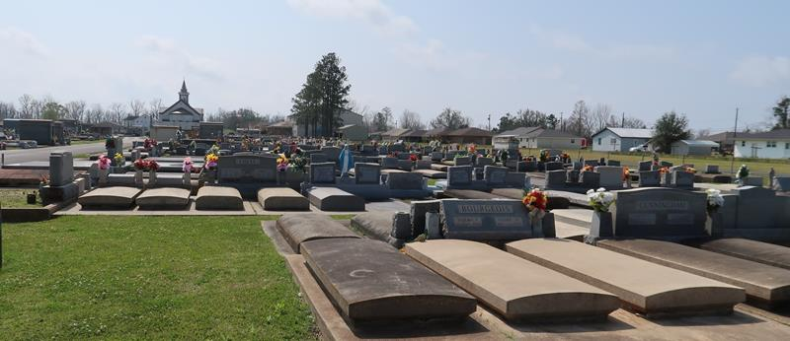

Malcolm Roberts a resident of Lutcher passed away on Saturday, March 7, 2026 at the age of 76.
Beloved husband of Eleanor Roberts for 54 years. Loving father of Damian Roberts (Angel), Tammy Dunn (Daniel), Bryce Roberts (Krystal). Grandfather of Tyler Roberts, Joshua Dunn, Abbie Roberts, and Connor Dunn. Son of the late Robert Joseph Roberts and Rosemary Bourgeois Roberts. Brother of Christine Scioneaux (Donovan), Cathy Triche (Al), Jeaniece Polk (Jimmy) Claire Webre (“Tiger”), and the late Wayne Roberts (the late Sally). Also survived by numerous nieces, nephews, and cousins.
Relatives and friends are invited to attend the Visitation and Funeral Services on Monday March 16, 2026, at Sacred Heart Church in Gramercy. Visitation from 9:00 am- 11:00 am, with the Funeral Mass to start at 11:00 am. Burial to follow the services at St. Joseph Mausoleum.

Rose Lynn Funeral Home, Lutcher, Louisiana
March 17, 2026

