Joseph D. Roussel

April 28, 1926 – December 11, 2015

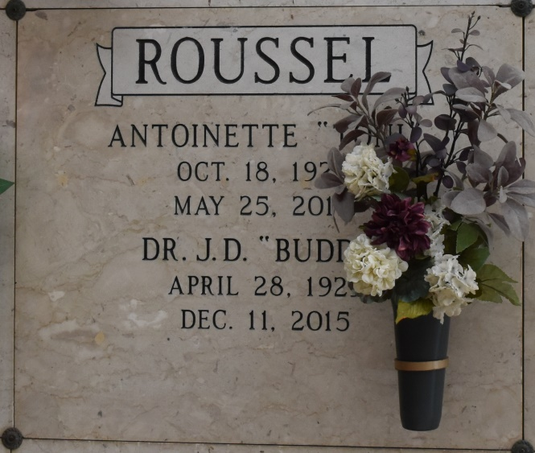

Joseph "Buddy" Roussel, a native of St. James Parish and resident of Baton Rouge, died at his resident on December, 11, 2015 at the age of 86. He graduated from Lutcher High School where he was a member of the Football and Basketball teams. Dr. Roussel was a professor of Animal Physiology in the Dairy Science Department at LSU where he conducted research and authored numerous publications. Dr. Roussel was also a consultant in the field of agriculture. He was a veteran of the U.S. Army serving during the Korean Conflict. He was an active member of St. Thomas More Catholic Church where he served as an usher. Buddy served his community as a member and Past President of the Downtown Lions Club and was a member and director of several professional Cattleman Associations.

Buddy is survived by his son, Fabian Roussel and wife, Monique; daughter, Alana R. Vaughn and husband Eddie; his grandsons, Robert Vaughn and Ryan Miller; his sister, Camille Cambre and brother, Kenneth Roussel. Preceded in death by his wife, Antoinette "Toni" Roussel; and parents, Adolph and Lucille Roussel.

Visitation will be at St. Thomas More Catholic Church on Tuesday, December 15, 2015 from noon until Mass of Christian Burial at 2pm officiated by Rev. Tom Duhe. In lieu of flowers, donation may be made to Mary Bird Perkins Cancer Center. The family wishes to express their sincere appreciation to Dr. David Hanson and staff for the wonderful care given to Buddy. He was an avid fan and supporter of LSU athletics. "GEAUX TIGERS"

Published by The Advocate (Baton Rouge, LA) from Dec. 12 to Dec. 14, 2015.