Sandra (Lambert) Roussel
December 9, 1942 - April 29, 2026

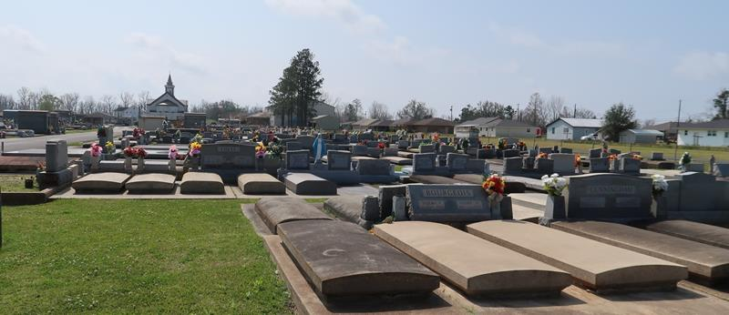

Sandra Lambert Roussel passed away peacefully on April 29, 2026, at the age of 83. She was a native of Convent, LA, and a resident of Lutcher, LA.
She surrounded her family with deep love and wholehearted devotion. She is survived by her children, Kimberly Duhe (Mark), Roger Roussel, III (Lori) and Paige Robinson (Paul), her grandchildren Jordan and Mason Duhe, Mallory D. Poirrier (Jordan), Heather R. Bosco (Colin), Heidi R. Balado (Beau), Michaela Raye, Micah, Preston, and Ashlyn Robinson, and great grandchildren Norah, Cannon, Charlotte and Margot Poirrier, and Elijah Bosco. She is also survived by her siblings Merlyn St. Pierre, Dale Lambert, and Mary Champagne (Ralph), and numerous nieces and nephews. She was preceded in death by her loving husband, Roger "RJ" Roussel, Jr., her parents Eusebe and Hilda Lambert, and Siblings Arthur and Laverne "Winky" Lambert.
Sandra's greatest joy was her family, and she deeply cherished her children, grandchildren, and great-grandchildren. She treasured time spent dining at her favorite restaurants with family and friends. She took great pride in maintaining a tidy home. Each spring, she found joy in planting flowers in her flowerbeds. She had a deep love for traveling the world, with a special fondness for cruises. She will be dearly missed by her family and friends.
The family would like to extend their heartfelt appreciation to the staff and community of Azalea Estates of Gonzales for their compassion and kindness.
Relatives and friends are invited to attend the Visitation and Funeral Mass at St. Joseph Catholic Church, 2130 Rectory St., Paulina, LA, on Monday, May 4, 2026; Visitation at the church from 9:00 a.m. to 11:00 a.m. followed by a Funeral Mass at 11:00 a.m. Interment in St. Joseph Mausoleum, Paulina, LA.
Memorial donations may be made to the American Cancer Society in the memory of Sandra Lambert Roussel.

Rose Lynn Funeral Home, Lutcher, Louisiana
May 13, 2026

