# Flora Mae (Roussel) Schexnayder

November 1, 1929 - July 2, 2023

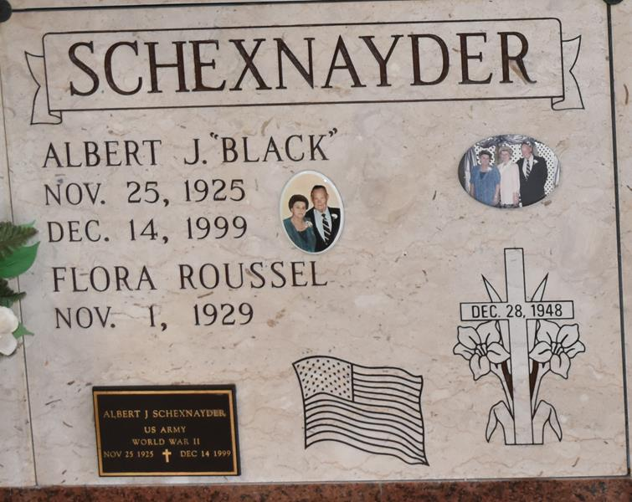

Flora Mae “Nookie” Roussel Schexnayder born on November 1, 1929 and passed away on July 2, 2023, at the age of 93. Survived by a daughter Nettie Oubre, preceded in death by her husband of 51 years, Albert “Black” Schexnayder, her parents Ludivine Faucheux and Hamilton Roussel, her siblings Clotilde Tregre, Aubert Millet, Bert, Wallace, and Rose “Geet” Roussel. Survived also by numerous nieces and nephews.

She will be greatly missed by all who love her. She was a proud volunteer of Saint Jospeh Altar for 15 years.

Relatives and friends are invited to attend the Visitation and Funeral Mass at St. Jospeh Church, 2130 Rectory St., Paulina on Thursday, July 6, 2023. Visitation at the church from 9:00 a.m. to 11:00 a.m. with the Funeral Mass to follow at 11:00 a.m. Burial in St. Jospeh Mausoleum, Paulina, LA.

Arrangements by Rose Lynn Funeral Home.  To view or sign the online guest book, please visit [www.roselynnfuneralhome.com](http://www.roselynnfuneralhome.com/).

Rose Lynn Funeral Home, Lutcher, Louisiana

July 4, 2023