Marie Helena (Ory) Schexnayder

August 4, 1865 – January 24, 1940

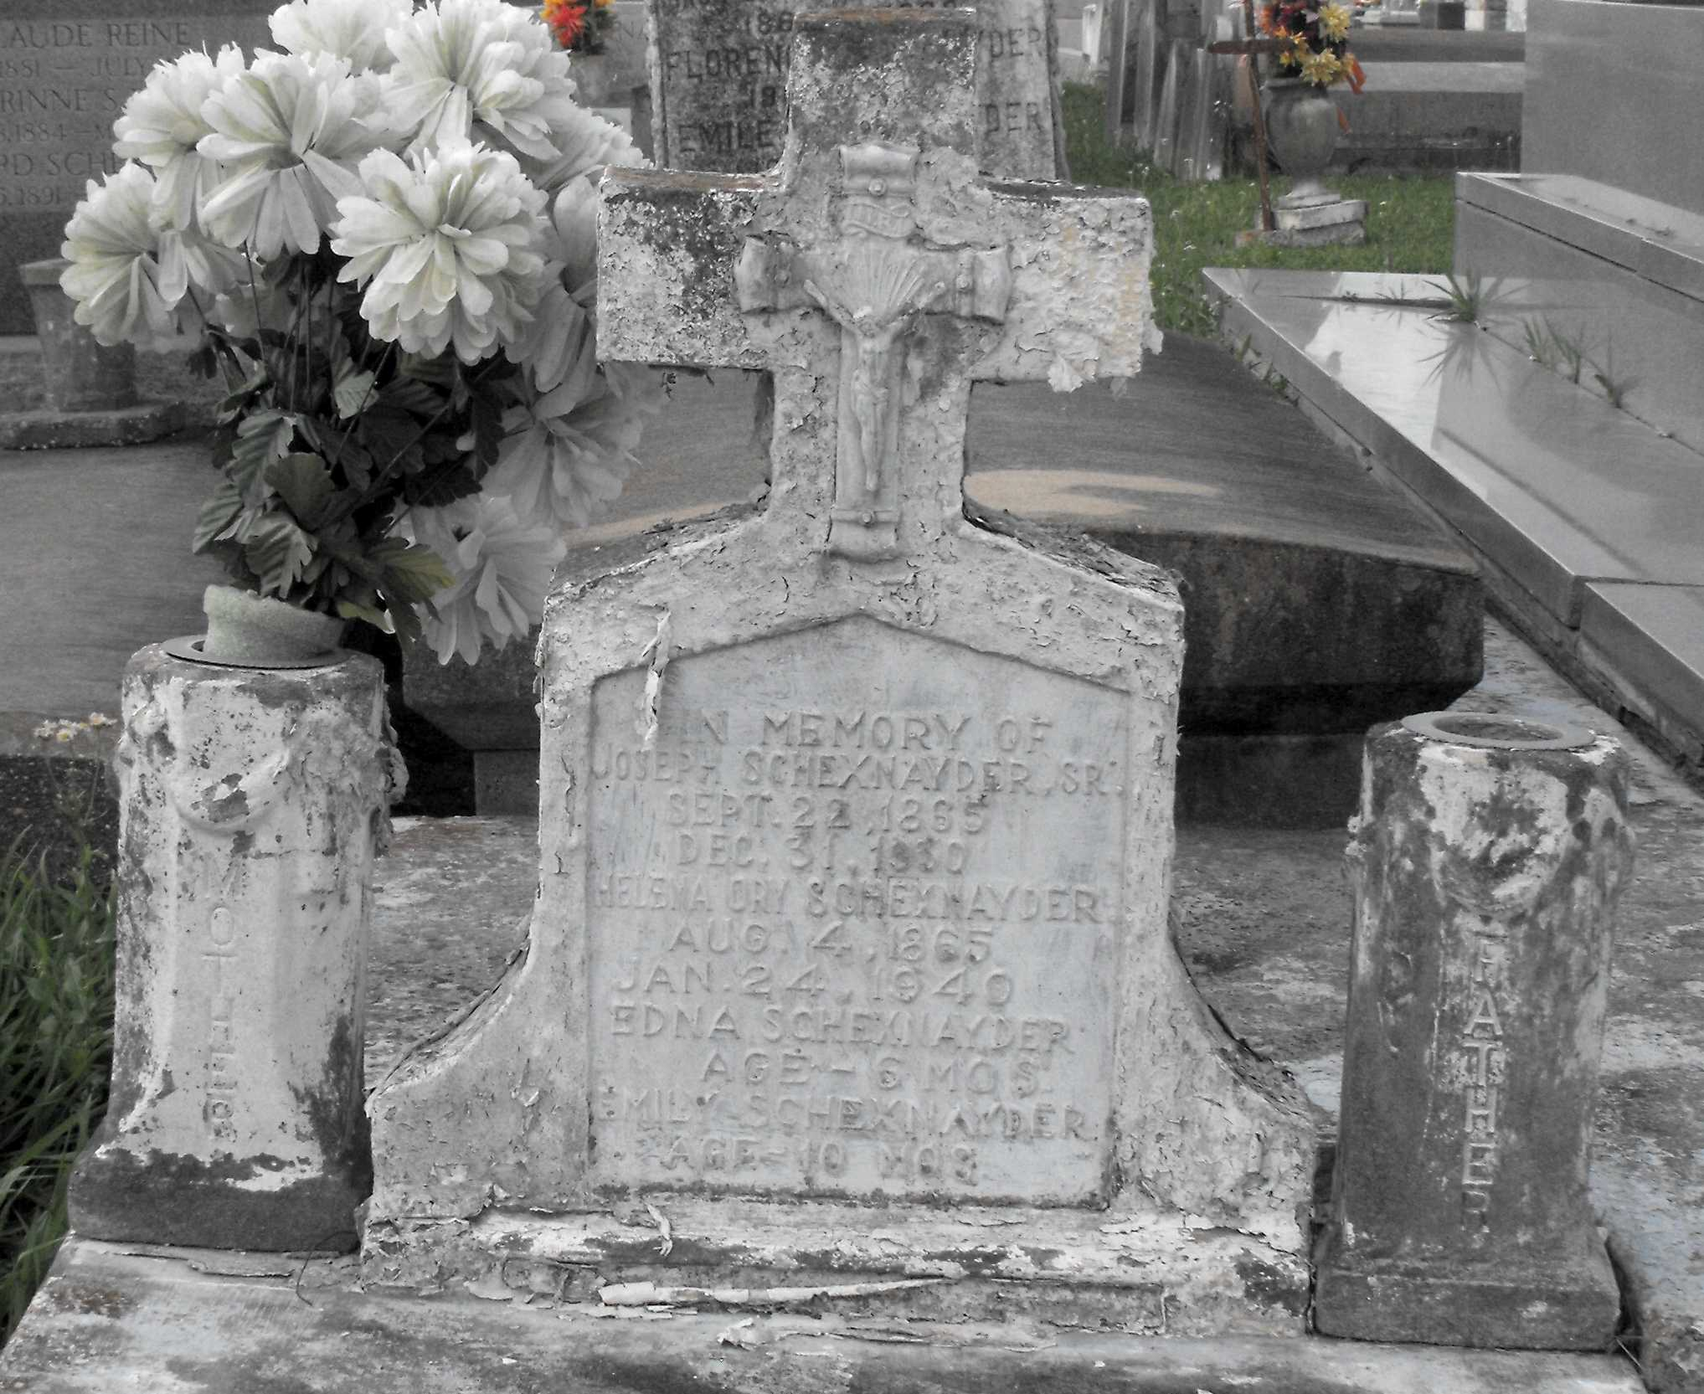

Photo by Mary Agnes Hammett

Died at Lutcher, Louisiana, at age 74 years. She was the wife of the late Joseph Schexnayder Sr. and the mother of Clovis Schexnayder of Gramercy, Louisiana, Joseph Schexnayder Jr. of New Orleans, Mrs. Joseph [Antoinette] Pizzuto of Lutcher and Mrs. Rene [Odile] Bourgeois of New Orleans. Services were Thursday, 25 Jan 1940 at St Joseph Church, Paulina, Louisiana, with interment in St Joseph Cemetery.

From Obituary, The Times-Picayune, New Orleans, Louisiana; 25 Jan 1940

Contributed by Dwayne Montz