Barbara Jean Skinner
October 31,1947 - May 28, 2025

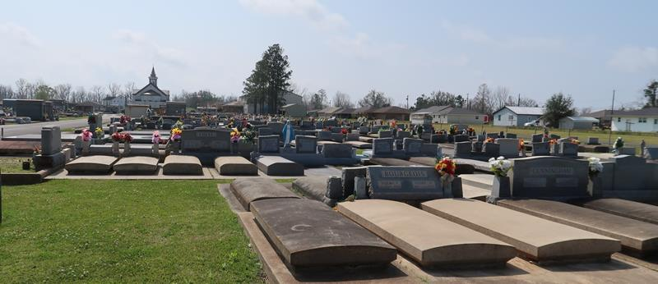

Barbara Jean Skinner was born on Friday, October 31, 1947 in Lutcher, Louisiana to the late Sam and Ethel Skinner, Sr. She was one of six children. Barbara attended Cypress Grove High School. Barbara was called home to be with the Lord from her home in St. Rose, Louisiana on Wednesday, May 28, 2025. She was 77 year old.
We all knew Barbara for her strong will and determination. She worked sixteen years for Aircraft Service International Group as a fuel server operator. Barbara always knew the importance of family it’s no surprise that favorite foods were all perfect for sharing. She enjoyed spending time with the children within her family and friends.
She was preceded in death by her father and mother Sam and Ethel Skinner Sr.; sisters Orelia Skinner, Mary Skinner-Cummings, and Joyce Ann Skinner; brothers Ronald Isaac Skinner and Sam Skinner, Jr.
She leaves to cherish her memories her daughter Charmaine Skinner; granddaughter Rodyn LeBeau; uncle Dennis Washington and a host of nieces, nephews, cousins, other relatives and friends. She touched many lives and will forever live on in the hearts and memories of those who knew and loved her.
A Celebration of Life will be held on Saturday, June 14, 2025 at Greater King Triumph Baptist Church, 2572 Lionel Washington St, Lutcher, LA 70071. Visitation begins for 8am followed by the service at 10am. Interment St. Joseph Catholic Church Cemetery, 2130 Rectory St, Paulina, LA 70763.

Treasures of Life Funeral Services, Gramercy, Louisiana
June 13, 2025

