Mattie (Barnes) Taylor Smith
September 1, 1932 - April 24, 2025

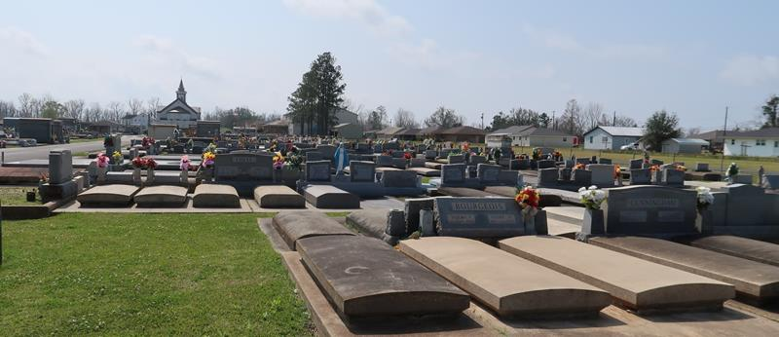

"I will bless the Lord at all times; His praise shall continually be in my mouth. My soul shall make its boast in the Lord; The humble shall hear of it and be glad. Oh, magnify the Lord with me, and let us exalt His name together." - Psalm 34:1-3
Mother Mattie Taylor Smith, born September 1, 1932, in Merigold, Mississippi, was the fourth child of Eddie Grover Barnes and Pearlena Cain Barnes. She accepted Christ at an early age and was baptized at Bright Star Missionary Baptist Church by the late Rev, Chaney. Mother Mattie attended the public schools in Bolivar County, where children of color could complete up to the 8th grade. Limited opportunities in Merigold led Mother Mattie to seek a better life in New Orleans, Louisiana. After arriving in New Orleans, she was employed at Newcomb College and later met the love of her life, William Taylor Jr. They were married and moved to Lutcher, where they were blessed with eight children to rear.
Knowing the importance of a relationship with God, Mother Mattie joined the Israelite Baptist Church under the leadership of her father-in-law, Rev. William Taylor. There she served faithfully as a deaconess. She experienced much joy as she served with the Nursing Home Ministry, bringing the word of God, games, and treats to the residents. Recognizing the Importance of education, she attended night classes and earned her high school diploma despite having young children and facing many obstacles. She encouraged all her children with the same determination. Mother Mattie's thirst for clarity of God's word led her to study at Daughters of Esther Fellowship International Ministries, Inc. She was ordained a minister of the Gospel on November 1, 2001. In 2004, she joined Prevailing Faith Ministry with the late Pastor Bernard Lee, along with Pastor Kathleen Lee. There she was mother of the church, a minister of the Gospel, a prayer warrior, a member of the Prison Ministry, and a Bible class teacher for the Lutcher Senior Citizens Center. Her favorite scripture was Psalms 34:1-3. Her favorite hymn was "I Am on the Battlefield for My Lord."
In 2005, Mother Mattie married the late Henry Smith as they applied the principles expressed in Proverbs 18:2Z to their lives. Mother Mattie was preceded in death by her parents, four brothers, three sisters, one great-grandson, Dandre Woodley, and one great-great granddaughter, Kamryn Prembrook.
She leaves to cherish her memory eight children: Elizabeth Johnson (Dalton), Willie Taylor (Edna), Patricia Ruffin (Weldon), Cedric Taylor (Claudia), Paulette LeBlanc (Lawrence), Mattie Lee, William Taylor Ill, and Linda Coleman (Timothy): she leaves to cherish also her memory of 21 grandchildren, 39 great-grandchildren, and 12 great-great-grandchildren.
As we remember Mother Mattie, let us honor her life by continuing to magnify the Lord and share His love with others, just as she did. Join the family for a Celebration of Life for Mattie on Friday, May 2, 2025 at King Solomon Baptist Church, 2385 N Courseault St, Lutcher, LA 70071. Visitation begins for 8am followed by service 10am. Interment St. Joseph Cemetery, 2130 Rectory St, Paulina, LA 70763.

Treasures of Life Funeral Services, Gramercy, Louisiana
May 1, 2025

