Blanca Maria (Lamarche) Soriano
May 14, 1942 – August 21, 2025

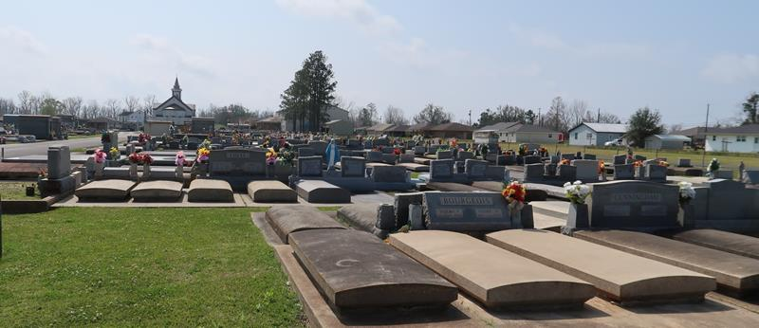

Blanca Maria Lamarche Soriano, a native of the Dominican Republic and longtime resident of Lutcher, Louisiana, passed peacefully into eternal rest on August 21, 2025, at the age of 83. Her life was a quiet testament to grace, faith, and enduring love.
Born to Maria Patin and Juan Bautista Lamarche, Blanca was raised in a home shaped by tradition and devotion. After losing both parents at age 14, she found strength in the love of her older siblings, Juan Miguel Lamarche and Maria Teresa Hecht. That early loss deepened her compassion and shaped the quiet resilience she carried throughout her life.
She was married for 38 years to Cesar Bartolome Soriano, who preceded her in death in 2000. Together, they built a life grounded in faith and family, raising four children: Blanca Maria S. (Delio) Perez, Bartolome Antonio Soriano (Lissette), and twins Miguel Angel Soriano (Lesly) and Angel Luis Soriano (Chantel). Her love extended to her grandchildren—Michael Anthony Perez, Samuel Angel Soriano, Alexander Luis Soriano, Jonathan Michael Soriano, Andre Jose Soriano, and the late Scarlett Maria Perez, whose brief life was held tenderly in Blanca’s heart.
Blanca cherished travel and found joy in the movies, often taking her children to the theater on weekends—simple outings that became treasured rituals. She moved permanently to the United States in 1994, living near her daughter in Augusta, Georgia, where she remained active and independent for 24 years. In 2018, as her health declined, she relocated to Lutcher to be near her son and his family, surrounded by care and love.
Her Catholic faith was the foundation of her life. She prayed daily, often with a rosary in hand and a small statue of Our Lady of Guadalupe nearby. Her devotion to St. Anthony was quiet but profound—she believed in his power to restore what was lost, whether peace, strength, or hope.
A memorial will be held on Saturday, August 23, 2025 at St. Joseph’s Church, 2130 Rectory St, Paulina, LA 70763 beginning at 10:00 AM , followed by a Prayer Service in her honor, starting at 11:00 AM. Burial will immediately follow in St. Joseph Cemetery.
Now resting in God’s eternal embrace, Blanca’s soul rises like incense to heaven—where prayers become praise, and love never ends. In lieu of flowers the family is requesting donations to St. Jude Hospital, in Blanca's name.

Rose Lynn Funeral Home, Lutcher, Louisiana
August 23, 2025

