Florence Mary (Martin) St. Pierre
February 13, 1924 – March 14, 2022

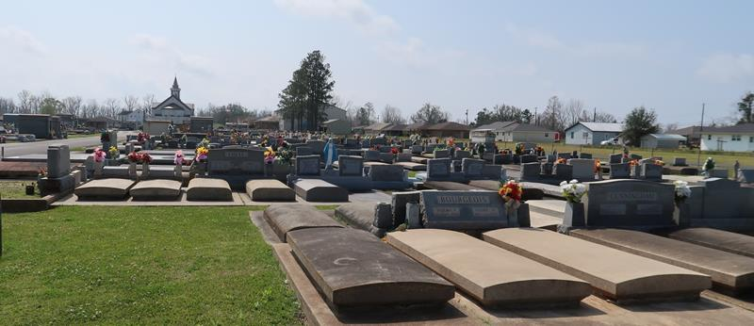

Florence Martin St. Pierre passed away peacefully on Monday, March 14, 2022, at the age of 98 surrounded by her loving children. Mrs. St. Pierre was a lifelong parishioner of St. Joseph Catholic Church in Paulina, LA. She was a member of the Catholic Daughters. She also was a faithful Adorer at the Adoration Chapel. Her devout love for the Lord was evident through all her life.
She is survived by her children, Beryl (Wayne) Bourgeois, Marlyn (Ricky) Jacob, Dale St. Pierre, Karen (Brent) Ocmond, and JoAnn Speaks; grandchild-ren, Laurie (Eric) Anders, Gale (Chris) Weber, Rusty (Melissa) Jacob, Andre (Nancy) Elfer, Dana Jacob, Cullen (Andi) Ocmond, Beth (Adam) Millet, Scott (Rachel) Ocmond, Toby Jacob, Cristy Laiche, Christopher (Halie) Speaks, Robbie (Katie) Ocmond, and Casie (Brian) Harrison; 30 great-grandchildren with one on the way; siblings, Theresa McCann, Bruce Martin, Willy Martin, and Jacob Martin; sister-in-law, Jeanette Guillaume; and numerous nieces and nephews.
She is preceded in death by her husband of 65 years, Morris J. St. Pierre; parents, Leonia Roussel Martin and Jacob Martin; daughter, Gale St. Pierre; grandchildren, Andrea and Jude; and siblings, Gordon Martin, Milton Martin and Marie Millet.
Visitation will be Thursday, March 17, 2022, at St. Joseph Catholic Church in Paulina, LA from 9:00 am until the funeral mass at 11:00 am. Burial will follow in the church cemetery.

The Advocate, Baton Rouge, Louisiana
Mar. 15 to Mar. 17, 2022

