Paula (Roques) St. Pierre
March 29, 1953 – March 8, 2026

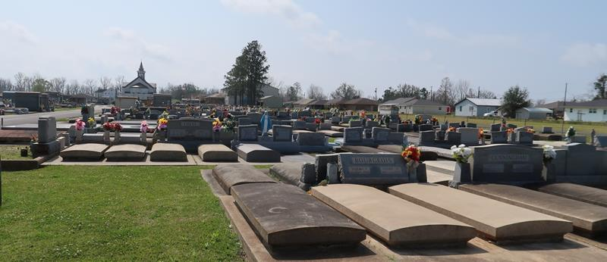

Paula Roques St. Pierre a resident of LaPlace, LA passed away on Sunday March 8, 2026 at the age of 72.
Loving mother of Jeremy St. Pierre (Melanie). Grandmother of Madison and Brady St. Pierre. Daughter of the late Pascal Paul Roques and Lucille Roussel Roques. Sister of Dianne Boice (Jeff), Joan Kinler (Ellis), Dennis Roques (Debbie), Juanita Roussel, Cindy Millet (Craig), Jeffery Roques, and the late Glenn Roques. Also survived by numerous nieces, nephews, and cousins.
Paula’s faith in God was unwavering and was an avid volunteer at Ascension of Our Lord Church in Laplace.
Relatives and Friends are invited to attend the Visitation and Funeral Mass at Ascension of Our Lord,1900 Greenwood Dr. Laplace, LA on Monday March 16, 2026. Visitation from 10:00 am -12:00 pm with the Funeral Mass to begin at 12:00 pm. Burial will follow the service at St. Joseph Cemetery in Paulina.

Rose Lynn Funeral Home, Lutcher, Louisiana
March 17, 2026

