Barbara (Terry) Thompson

November 24, 1922 – September 16, 2018

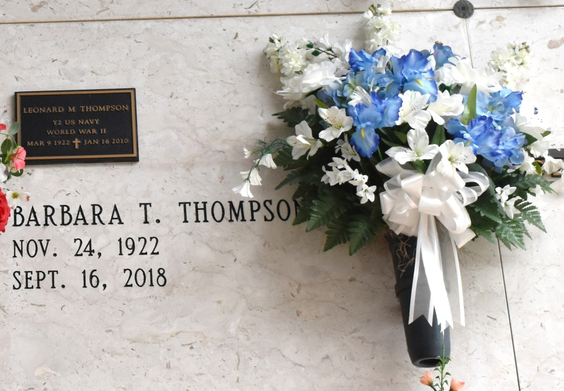

Barbara T. Thompson passed away on Sunday, September 16, 2018 at the age of 95. She was born on November 24, 1922 in New Orleans, Louisiana to Marie Alice and Frederick Terry II. She was the beloved wife of the late Leonard Thompson. Mother of the late Barbara Terry Thompson and the late Margaret "Peggy" Robert. She is survived by her siblings; Pat O'Drobinak and Frederick Terry III, her grandchildren; Sarah Robert (Darren Bueche) and Gary Robert II, and her son-in-law Ray "Chip" Robert. Barbara was a second grade teacher at St. Thomas More Elementary School. She truly loved being a teacher and helping the children. Barbara was an avid Saints fan and enjoyed spending time with her family. She will be greatly missed by all of those who knew her. Private services were held. To view and sign the guest book, please visit [www.HCAlexanderFuneralHome.com.](http://www.hcalexanderfuneralhome.com/)

Published by The Advocate (Baton Rouge, LA) from Sep. 21 to Sep. 23, 2018.