Renette (Wolfe) Turner
October 16, 1927 - August 15, 2025

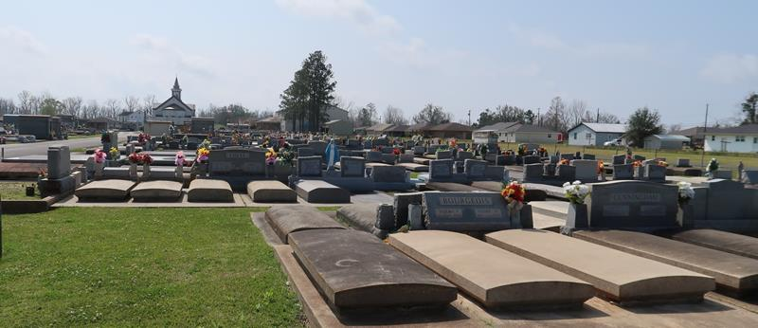

Renette was called to new life on August 15, 2025. She was born in Bay St. Louis, MS on October 16, 1927, and was a resident of Gramercy, LA since 1952. Renette was a 1947 graduate of Northwestern University, Chicago, with a degree in Dental Hygiene. She was a member of the Third Order of Mary and of Sacred Heart Church in Gramercy. Renette was very active in the Church and in providing comfort and support to others throughout the community.
Renette was preceded in death by her husband, Ward Turner, M.D., her two daughters, Cheryl Turner Mary and Paula Turner Ellis, grandson David Ellis, son in law James Richard Mary, and her two sisters and brother. She is survived by her two sons, Glenn Turner (Ann) and Joe Turner, M.D. (Candy, M.D.), son in law Byron Ellis, eight grandchildren and their spouses, and four great-grandchildren.
Services are on Saturday, October 4, 2025, at Saint Joseph Catholic Church, 2130 Rectory St, Paulina, LA 70763. Visitation is in the church from 9 am until 10:45 am. Mass is at 11 am, followed by interment at Saint Joseph Mausoleum in Paulina.
We are unable to receive flowers at the church. In lieu of flowers, Masses or memorial donations may be made to Sacred Heart Church, P.O. Box 129, Paulina, LA 70763, or a charity of your choice.

Rose Lynn Funeral Home, Lutcher, Louisiana
September 26, 2025

