Mary Frances (Lambert) Veron

June 9, 1937 – September 27, 2003

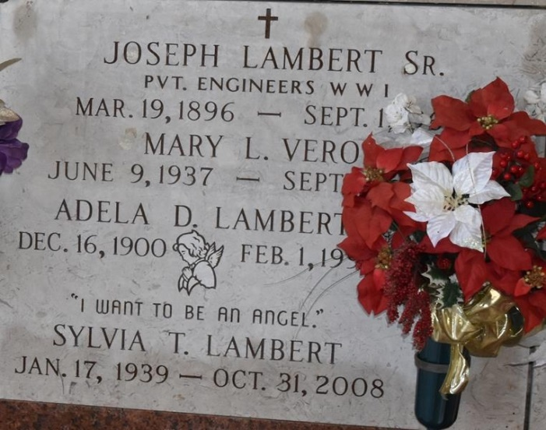

Mary Frances 'Cooney' Veron Passed Away On Saturday, September 27, 2003 At Riverlands Health Care Center. A Native Of Lutcher And Resident Most Of Her Life. Mrs. Veron Was A Homemaker. Aged 66 Years.  
 Daughter Of The Late Joseph Lambert And Adela Dupuy Lambert. Mother Of Mark Veron And Wife Melissa, Donna Waguespack And Husband Craig, Margaret Pearce And Husband Danny, Mary Frances Sullivan And Husband Bill And Joann Melancon. Sister Of Sylvia Lambert, Janis Leblanc, Catherine Leblanc, Thilda Maiorana, And The Late Lowell Lambert And Janet Leblanc. She Is Also Survived By 15 Grandchildren.  
 Family And Friends Are Invited To Attend The Funeral Service. A Mass Of Christian Burial Will Be Held At 11am On Tuesday, September 30, 2003 At St. Joseph Catholic Church, Paulina, La. Entombment To Follow In Church Mausoleum. Visitation Will Be Held In The Church On Tuesday From 8:30am Until Mass Time.  
 Arrangements Under The Direction Of Alexander Funeral Home,  
  
Times Picayune, New Orleans, Louisiana

July 29, 2003