Aimee Marie (Guidry) Vicknair

March 3, 1888 – May 19, 1954

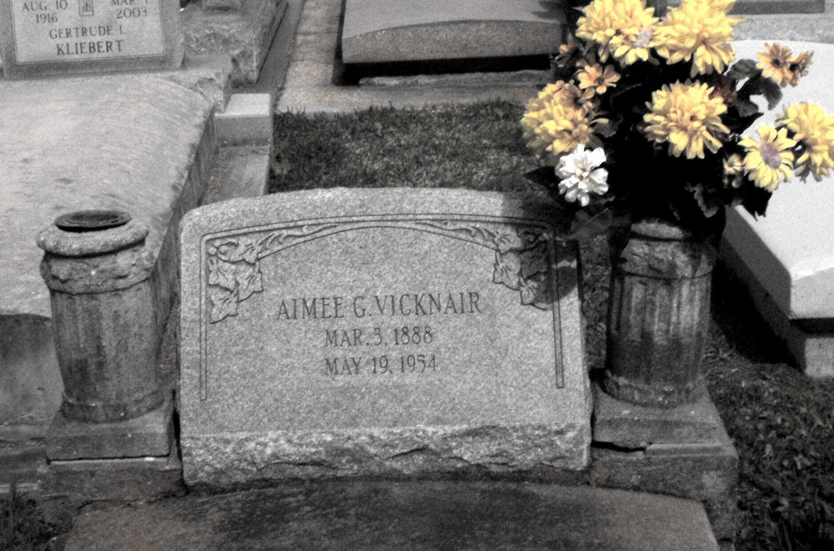

Photo by Mary Agnes Hammett

VICKNAIR - In New Orleans, La, on Wednesday, May 19, 1954, at 5:25 o'clock p.m., AMY MARIE GUIDRY, wife of the late Leonce Vicknair Jr; mother of Lawrence Vicknair of Gramercy, La, Clovis and Paul Leonce Vicknair of Paulina, La, Albert and Earl Vicknair of Baton Rouge, La, Mrs. Harris Schexnayder, Mrs. George Rome of Lutcher, La, Mrs. Theophile Rouques of Paulina, La, and Mrs. Louis Gaudet of Baton Rouge, La; aged 66 years. Relatives and friends of the family are invited to attend the funeral, which will take place from the Alexander Funeral Home, Lutcher, La, on Friday, May 21, 1954, at 9 o'clock a.m. Religious services at St Joseph's church, Paulina, La. Interment in St Joseph's cemetery, Paulina, La.

OBITUARY, The Times-Picayune, 20 May 1954, p 2

Contributed by Dwayne Montz