Paul Neil Webb

April 30, 1925 – October 10, 2004

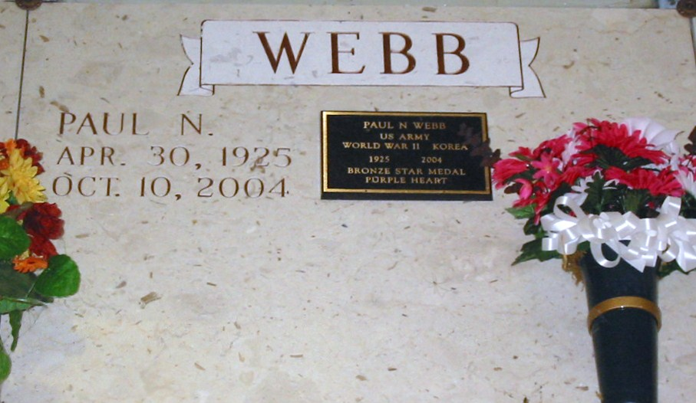

Photo by Bobby

Paul Neil Webb, Age 79, Born On April 30, 1925, And Died On Sunday, October 10, 2004 At 12:20 A.M. A Native Of Townsend, Tennessee And A Resident Of Gramercy, La. Mr. Webb Is Retired From The United States Postal Services. He Is A Member Of The VFW, Post 5852 In Lutcher, La. And Is Retired From The U.S. Army; And A Recipient Of The Bronze Star And Purple Heart Award.  
 Paul Is Survived By His Beloved Wife Of 50 Years, Lee E. Carriere Webb; Two Daughters: Deborah Webb And Malinda Rein And Husband Keith Rein; Two Sisters: June Kimsey And Juanita Gheens; And Four Grandchildren: Jared Peranio, Kristin Peranio, Eric Rein And Lance Rein.  
 Preceded In Death By His Parents: Frank And Blanche Myers Webb; And Two Brothers: Howard And Hugh Webb And One Sister Beaulah Webb.  
 Visitation Will Be On Wednesday, October 13, 2004 From 8:00 A.M.-1:00 P.M. At Rose Lynn Funeral Chapel In Lutcher, La.; With A Memorial Service Taking Place At 1:00 P.M.; Followed By Interment At St. Joseph Mausoleum In Paulina, La. Rose Lynn Funeral Services Is In Charge Of Arrangements.

Times Picayune, New Orleans, LA; October 12, 2004

\*\*\*\*\*

LUTCHER – Paul Neil Webb, 79, a native of Townsend, Tenn., and resident of Gramercy, died Oct. 10. He was the husband of 50 years of Lee E. Carriere Webb and father of Malinda Rein and Deborah Webb. He was also the son of the late Frank and Blanche Myers Webb, and brother of June Kimsey, Juanita Gheens, and the late Beulah, Howard and Hugh Webb. He is also survived by four grandchildren.

He was a U.S. Army retiree, recipient of the Bronze Star and Purple Heart, and a member of VFW Post 5852. He was also retired from the U.S. Postal Service.

Memorial services are today at 1 p.m., in the chapel of Rose Lynn Funeral Home, Lutcher, with interment at St. Joseph Mausoleum, Paulina. Visitation starts at 8 a.m.

L’Observateur, LaPlace, Louisiana; Thursday, October 14, 2004