George Philip Weidert
May 28, 1941 - May 17, 2026

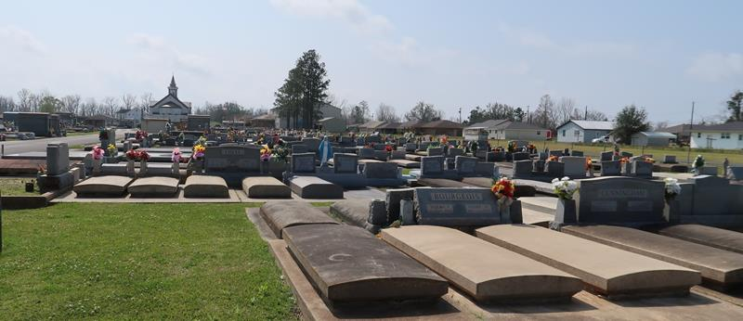

George Philip Weidert, a native of Mt. Airy, LA, and resident of Gramercy, LA, passed away peacefully on Sunday, May 17, 2026. He was the husband of the late Linda Roques Weidert, and the father of Christel Weidert Scott, Chad (Susan) Weidert, and the late Eric Weidert. He was the son of the late Arthur and Agnes Weidert, and the brother of the late Dale, Wayne, Richard and Greer Weidert.
George is also survived by his grandchildren, Nicole Trosclair, Chase (Catherine) and Dustin (Casey Myers) Weidert, and Emily W. (Jeremiah) Berteau, as well as his four great-grandchildren, Drake Gravois, Harper Weidert, Dillon Trosclair, and Aubrey Berteau, and numerous nieces and nephews.
He was proceeded in death by his wife, Linda; son, Eric; grandsons Jonathan Trosclair and Dylan Bonck; and son-in-law Keith Scott.
George was a retired employee of Colonial Sugars (Imperial) in Gramercy. He was an amazing craftsman who built his own house in Gramercy, as well as two camp houses in Chauvin. In his spare time, he enjoyed hunting, shrimping, and being at his camp.
Relatives and friends of the family are invited to a visitation at Sacred Heart Church in Gramercy, LA on Thursday May 21, 2026 from 9:00-11:00 am, followed by a Mass of Christian Burial at 11:00 am. Interment will be at the St. Joseph Church Mausoleum in Paulina, LA.
The family wishes to express their deep gratitude to Dr. Cullen Ocmond and the staff of St. James Parish Hospital, AGI Hospice and his caregivers, Phoebe Ross and Paula Adams.

Rose Lynn Funeral Home, Lutcher, Louisiana
May 18, 2026

