Peggy (Arceneaux) Woods

October 25, 1928 – September 21, 2011

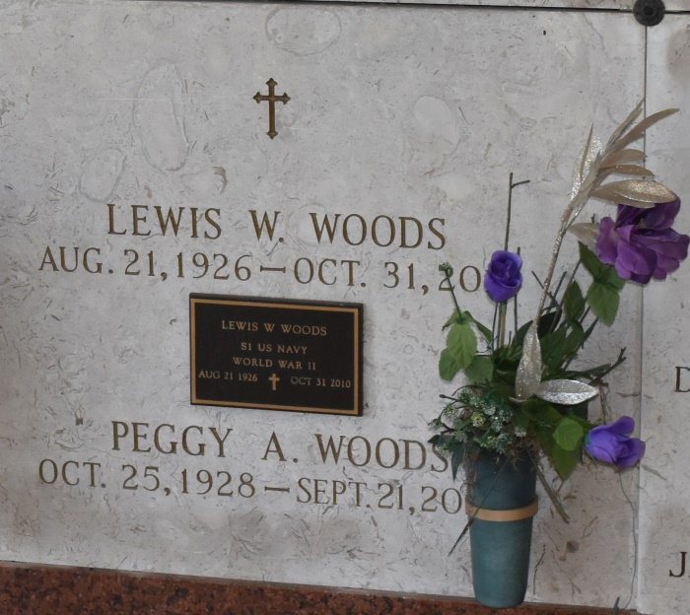

Peggy Arceneaux Woods was born on October 25, 1928 and passed away on September 21, 2011. She was a native of Hackberry, LA and a resident of Lutcher, LA.

She is survived by her children: Thomas and wife Sharon, Natalie Woods Plasters, Alvyn and wife Tammy, Yvonne "Missy" Woods, Sarah Woods, and Richard and wife Belinda. She is also survived by 8 grandchildren and 6 great-grandchildren.

She was preceded in death by her husband, Lewis W. Woods; parents, Charles Arceneaux, Sr., and Elsie Vincent Arceneaux; brothers, Charles Arceneaux, Jr., Michael Arceneaux, and a sister, Joan Arceneaux Granger.

She was a marvelous cook, dedicated to her family. She was the owner of a family restaurant "Airline Motors" where she worked side by side with her late husband.

Visitation will be on Friday, September 23, 2011 from 8:30 a.m. until 10:30 a.m. at Rose Lynn Funeral Home, 1870 Cabanose Ave., Lutcher, LA, followed by a Mass of Christian Burial at St. Joseph Catholic Church, Paulina, LA at 11:00 a.m. Burial in the church cemetery.

Unknown source