Kathleen Marie (Mire) Andermann
December 11, 1931 – October 23, 2021

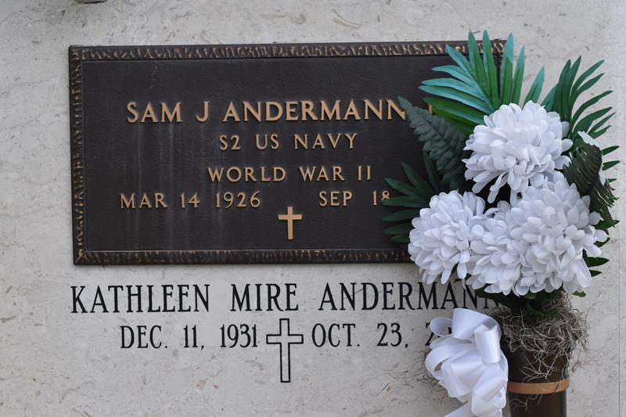

Kathleen Mire Andermann, a native of Central in St. James Parish and a resident of Union, LA., she passed away on Saturday, October 23, 2021. She was 89 years old. She enjoyed cooking, sewing, quilting and flower gardening; was a loving homemaker and friend to many.
Survived by her children, Paulette (Tim) Templet, Clark (Loretta) Andermann, Lisa (Gary) Kidd, Cary Andermann, and Carla (Rusty) Schexnaydre; her seven grandchildren, her twelve great-grandchildren; and her sister, Yvette Frederic.
Preceded in death by her husband, Sam "Buck" Andermann, Jr.; and her son, John Kevin Andermann. Pallbearers will be Brennan Templet, Zane Kidd, Ian Kidd, Grant Kidd, Derrick Andermann, and Luke Templet.
Visitation will be held on Wednesday, October 27, 2021 at St. Michael the Archangel Catholic Church in Convent, LA., beginning at 10:30 a.m. until mass of Christian Burial at 12 p.m. Entombment will follow at St. Mary Mausoleum in Union.
Special thanks to Dr. Brian Lindenmayer, Dr. Wilson Wang and Pinnacle Hospice along with their staff.

The Baton Rouge Advocate, Louisiana
October 25, 2021

