Samuel Joseph Andermann, Jr.
March 14, 1926 – September 18, 2004

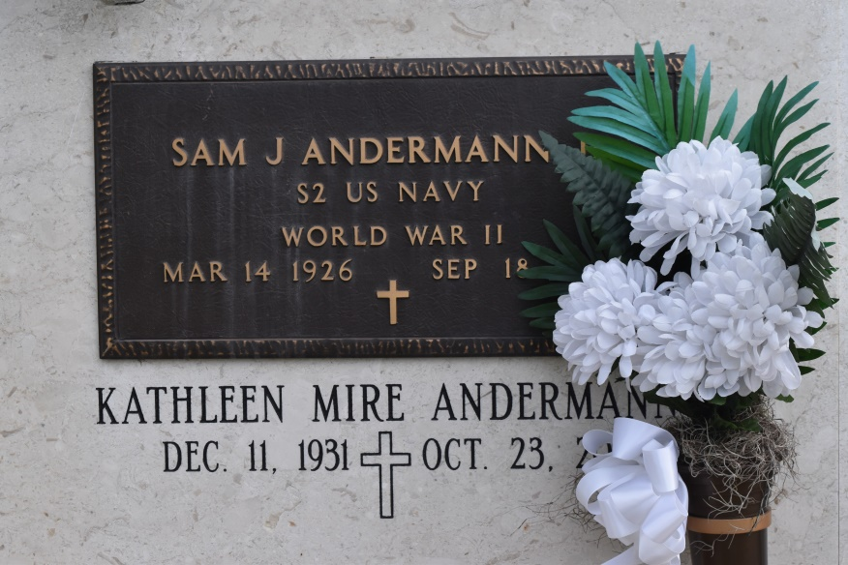

ANDERMANN JR., SAM J. "BUCK"

Died Saturday, Sept. 18, 2004, at 9:17 p.m. at his residence in Convent. He was 78 and a native of Union. He served in the U.S. Navy on the USS Cadmus during World War II and retired from Ormet Corp. in Burnside. He served as justice of the peace in St. James Parish Ward 4 for 18 years.
Visiting at St. Mary's Chapel in Union from 9 a.m. until Mass of Christian Burial at 11 a.m. Tuesday, Sept. 21, with the Rev. Ed Fuss, celebrant. Entombment in St. Mary's Catholic Church Cemetery.
Survived by his wife of 53 years, Kathleen Mire Andermann; children and their spouses, Paulette A. and Tim Templet, Clark P. and Loretta D. Andermann, Lisa A. and Gary Kidd, Cary Andermann, Carla A. and Rusty Schexnaydre and John Kevin Andermann; grandchildren, Brennan P. and spouse, Alisha P. Templet, Greta Ann Templet, Aaron and Adam Andermann, Zane, Ian and Grant Kidd; and great-grandson, Derrick Andermann.
Preceded in death by his parents, Sam and Edna Letulle Andermann; brothers, Norris and Russell Andermann; and sisters, Evelyn A. Bourgeois, Louella A. Folse and Loretta Andermann.
Welsh Funeral Home, 426 W. New River St., Gonzales, in charge of arrangements.
Advocate, The (Baton Rouge, LA) - Tuesday, September 21, 2004
Contributed by Jane Edson

