Fernand Jules Arcement
January 5, 1906 – August 5, 2002

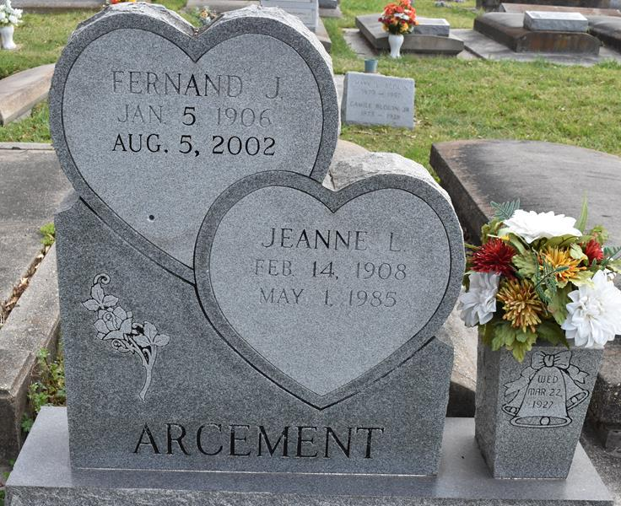

Fernand Jules ""Shawee'' Arcement, age 96 years, died on Monday, August 5, 2002 at 6:20 PM at I.H.S. Nursing Home in Gonzales, LA.
Husband of the late Jeanne Louviere Arcement. Father of Daisy Delaune of St. Amant, LA., Virgie Driskill of Metairie, LA., Rudy Arcement of Malino, FL., and the late Ethel Clouatre. Son of the late Henry and Henrietta Guillot Arcement. Brother of Marion Brinson of San Pedro, CA., Roland Arcement of Gretna, LA., and the late Sylvester, Paul, George, Junius, and Eddie Arcement, and Florance Kittle and Elvina Blank. Father-in-law of JR "Joe'' Delaune, Brent Driskill, Dorothy Arcement, and the late Cleo Clouatre. Brother-in-law of Louise and Kathleen Arcement both of Gretna. LA. Grandfather of JoAnn Bercegeay, Judy LaPorte, Terry, Barry, Dean Delaune, Mark Clouatre, Patty Spears, Deena Ehret, Brian Driskill, Debra McColskey, and the late Jane Clouatre and Kerry Delaune. Great-Grandfather of the late Nelson Joseph Clouatre. Devoted Friend of Katherine and Walter Hogg and Tony La Porte. Also survived by 20 Great- Grandchildren, 1 Great-Great-Grandson, several nieces, nephews, other relatives and friends.
He was born in Rayne, LA. on January 5, 1096, retired from Helvetia Sugar House, and a former resident of Gretna, Union, and St. Amant, LA.
A Mass of Christian Burial will be celebrated at St. Mary's Catholic Church, Union (Convent), LA. on Wednesday, August 7, 2002 at 2 o'clock PM. Interment in the church cemetery. Visitation from 11 AM until service time. WELSH FUNERAL HOME GONZALES, LA. IN CHARGE OF ARRANGEMENTS

The Times-Picayune, New Orleans, Louisiana
Aug. 7, 2002

