Lyle Christopher Benn
May 31, 1959 – May 8, 2010

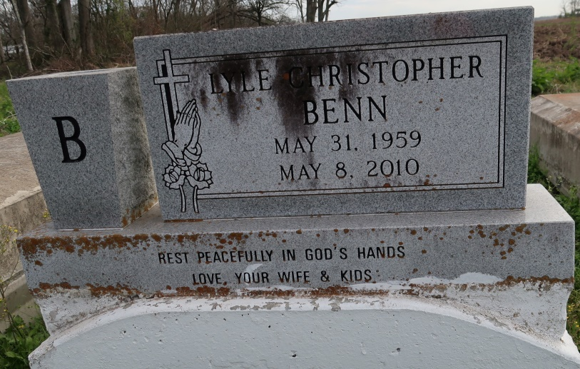

Lyle Christopher Benn

A resident of Convent and native of New Orleans, he died Saturday, May 8, 2010, in an automobile accident at age 50.
Visiting at St. James United Methodist Church, Convent, Saturday, May 15, from 9:30 a.m. until religious service at 11 a.m., conducted by the Rev. Gaynell Simon. Interment in St. Mary's Cemetery, Convent.
Survived by his wife, Dalphine Milton Benn, of Convent; four daughters, April, Jada and Chris Benn and Miranda Nicholas; three sons, Brian Nicholas and Jonathan and Jarren Benn; six sisters, Edith Jones, Donna Scott, Wanda Bush, Juanita Youngblood, Staphanie Benn, Lynn and spouse Charles Landry; three brothers and their spouses, Allen and Lota Benn, Wayne and Cynthia Benn and Comrad and Tgerri Benn; eight grandchildren; and mother-in-law, Margarite Ricard Milton. He was the brother-in-law of Joyce Jones and spouse Willie, Marsha Thomas and spouse Victor, and Ray Morgan, and nephew of Dr. Felix and Candy Ricard, and Louise Gaudin. Also survived by cousins, other relatives and friends.
Preceded in death by his parents, Andrew and Corine Gaudin Benn; brother, Kenneth Benn; father-in-law, Joseph Milton; two sisters-in-law and brother-in-law. Arrangements by Brazier-Watson Funeral Home, Donaldsonville.
Advocate, The (Baton Rouge, LA) - Friday, May 14, 2010
Contributed by Jane Edson

