Clarence Nicholas Bergeron
March 24, 1918 – April 25, 2002

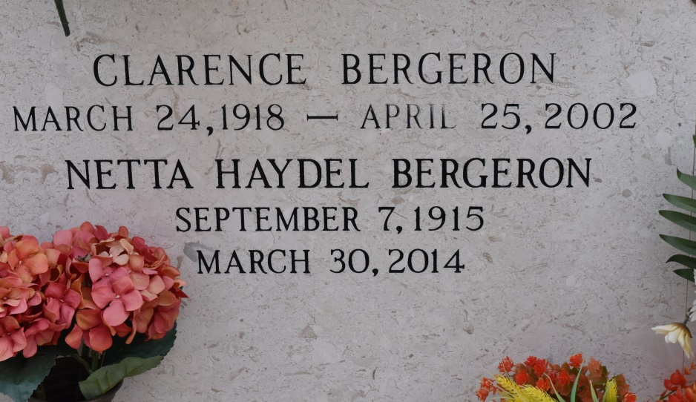

Clarence Nicholas Bergeron

A retired mechanic with Kaiser Aluminum & Chemical Corp. and a resident of Gonzales, he died Thursday, April 25, 2002, in Gonzales. He was 84 and a native of Union.
Survived by his wife of 62 years, Netta Haydel Bergeron, Gonzales; a daughter, Kay Bergeron, Gonzales; two sons and daughters-in-law, Donald and Karen Bergeron, St. Amant, and Lynn and Joan Bergeron, Gonzales; two sisters, Ruth Melancon, Convent, and Earline Mury, White Castle; a brother, Alfred "Be Be" Bergeron, Plaquemine; six grandchildren, Linette Guillory, Steve and Rob Bergeron, Stacy Jackson, Danielle Singletary and Patrick Bergeron; and six great-grandchildren, Jack and Shelbi Guillory, Zack Bergeron, Holli and Seth Jackson and Cole Singletary.
Preceded in death by his parents, Nicole and Alice Letulle Bergeron; a brother, John Bergeron; two sisters, Mabel Lanegrasse and Eula Mae Viguet.
Memorial donations may be made to Alzheimer's Services of the Capitol Area, 2041 Silverside Drive, Baton Rouge, LA 70808.
Gonzales Weekly Citizen (Ascension Parish, LA) - Thursday, May 2, 2002
Contributed by Jane Edson

