Netta (Haydel) Bergeron
September 7, 1915- March 30, 2014

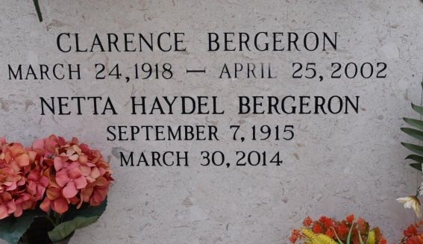

Gammy touched everyone's lives with love, kindness and dedication. A resident of Gonzales and native of Union, she passed away on Sunday, March 30, 2014 at the age of 98 at 1:03 am.
She is survived by her daughter, Kay Bergeron; two sons and daughters in law, Donald Bergeron and wife, Karen and Lynn Bergeron and wife, Joan; six grandchildren, Linette Guillory, Steve Bergeron, Rob Bergeron, Stacy Jackson, Danielle Calbert, and Patrick Bergeron; seven great grandchildren, Jake and Shelbi Guillory, Holli and Seth Jackson, Cole Singletary, Zach Bergeron, and Gavin Calbert.
She was preceded in death by her husband, Clarence N. Bergeron; parents, Etienne and Lovinia Letulle Haydel; sisters, Una Dicharry and Betty Mire; and a brother E.M. Haydel, Jr.
Visiting will be at St. Michael Catholic Church, Convent on Wednesday, April 2, 2014 from 9 am until Mass of Christian Burial at 11 am, Rev. Vincent Dufrense, officiating. Entombment to follow in St. Mary's Chapel Cemetery in Union. Pallbearers will be Steve Bergeron, Rob Bergeron, Patrick Bergeron, Scott Guillory, Paul Jackson, and Jake Guillory.
In lieu of flowers memorial donations can be made to the Children's Hospital of New Orleans, 200 Henry Clay Ave., New Orleans, LA 70118.
The family would like to extend a special thanks to the staff of Azalea Estates Retirement Community.
Please offer your condolences to the family at www.oursofh.com.

The Advocate, Baton Rouge, Louisiana
Mar. 31 to Apr. 2, 2014.

