Amelia Alice (Bourgeois) Boudreaux
February 23, 1888 – May 28, 1979

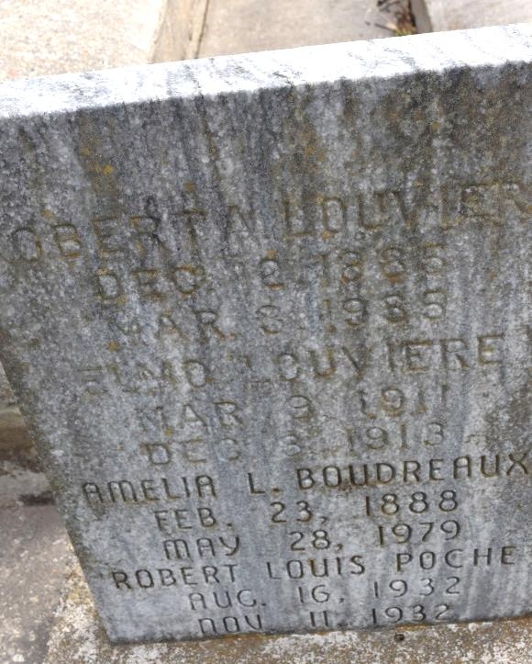

Mrs. Amelia Bourgerois Louviere Boudreaux, on Monday, May 28, 1979 at 5:10 pm at the Heritage Manor Nursing Home, mother of Mrs. Louis (Loretta) Poche of Norco, Roy Louviere of Gonzales, Clifford Louviere of Union, Lynn (Tony) Louviere of Norco, La., 18 grandchildren and 36 great grandchildren, mother of the late R. A. Louviere, Elmo Louviere, Mrs. Mamie Mayhall and Mrs. Margurite Zeringue; 91 yrs. of age, a native of Union, La., and a resident of Gonzales, La.
Relatives and friends of the family are invited to attend the funeral from the Welsh Funeral Home of Gonzales, on Wednesday, May 30, at 3:10 pm. Religious services at the St. Therese Catholic Church, Gonzales at 3:30 pm. Interment to be in the St. Mary's Cemetery in Union. Visitation on Wednesday, from 8 am until 3:10 pm.
Unknown source

