Elmore J. Boudreaux, Jr.
October 18, 1943 – March 21, 2000

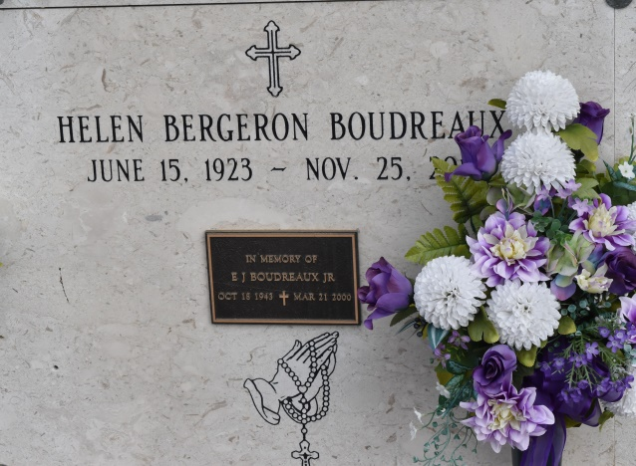

Elmore J Boudreaux, Jr. "E. J."

At age 56, he passed away at Bayou City Medical Center, Houston, on Tuesday, March 21, 2000. He was born in Convent on Oct. 18, 1943. He graduated from LSU in Baton Rouge and was employed as an engineer by Brown & Root/Halliburton in Houston for 32 years.
He is survived by his wife, Vicky in Houston; mother Helen; four brothers, Roy, Bryan, Roger and Henry; three sisters, Marie Ory, Denise Allen and Mona Logarbo; and 18 nieces and nephews, all residing in Louisiana.
Preceded in death by his father, Elmore J. Boudreaux.
Memorial services at St. Cyril of Alexandria Catholic Church, Houston, at 1 p.m. Saturday. In lieu of flowers, memorial contributions, if desired, may be sent to St. Cyril of Alexandria, 10503 Westheimer, Houston, TX 77042-3502.
Advocate, The (Baton Rouge, LA) - Friday, March 24, 2000
Contributed by Jane Edson

