Helen (Bergeron) Boudreaux
June 15, 1923 – November 25, 2016

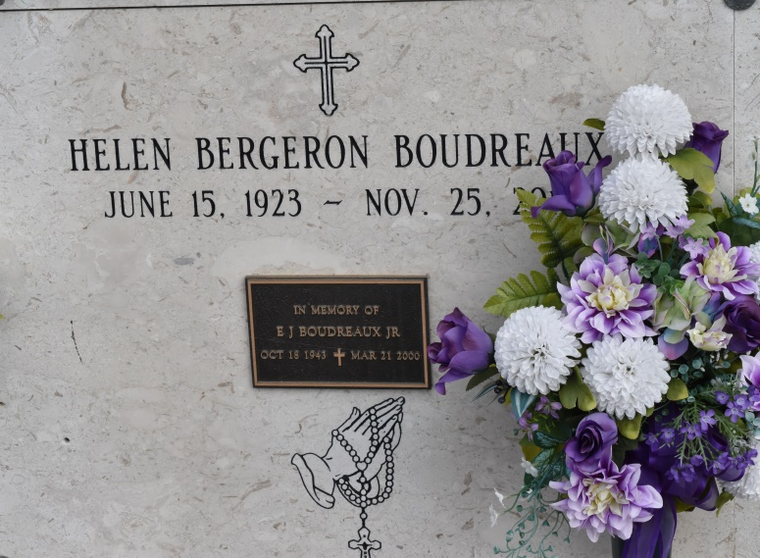

Helen Bergeron Boudreaux passed away on Friday, November 25, 2016 at her home in Union, La at the age of 93. She was born in New Orleans on June 15, 1923 to the late Henry Bergeron and Jeanne Letulle Bergeron. She was a devoted Catholic, a retired business owner, and the glue that held the family together hosting our Saturday night gatherings.
Survived by Daughters and son-in-laws: Marie and Johnny Ory, Denise and Kenny Allen, and Mona and Troy Logarbo Sons and daughter-in-laws: Roy and Catherine Boudreaux, Bryan and Mary Boudreaux, Roger and Cathy Boudreaux, Henry Boudreaux, and Vicky Valero, 16 grandchildren, 20 great grandchildren, and numerous nieces and nephews.
Preceded in death by Husband: Elmore Boudreaux; Son: E.J. Boudreaux Jr.; Baby brother Henry Bergeron Jr.; Granddaughter: Jessica Boudreaux Packer; Infant grandson: Kurt Allen; Sisters: June Ruble Magnitzky & sister Elaine Lane; Half-sister: Lucille Chauvin.
The family would like to especially thank her friend, Catherine Hogg and her niece Celeste Lane for their dedication and help, and also thank the staffs of St. James Hospital, Thibodeaux Regional Hospital and St. Joseph Hospice for their care in her final illness.
Visitation St. Michael's Catholic Church, Convent, LA, Tuesday, November 29, 2016, 9 AM - 11 AM. Mass of Christian Burial St. Michael's Catholic Church Tuesday, November 29, 2016, 11 AM. Burial St. Mary's Mausoleum, Union, LA.
H. C. Alexander Funeral Home, St. Charles Parish, LA

