Henrietta (Weber) Boudreaux
January 16, 1910 – January 14, 2002

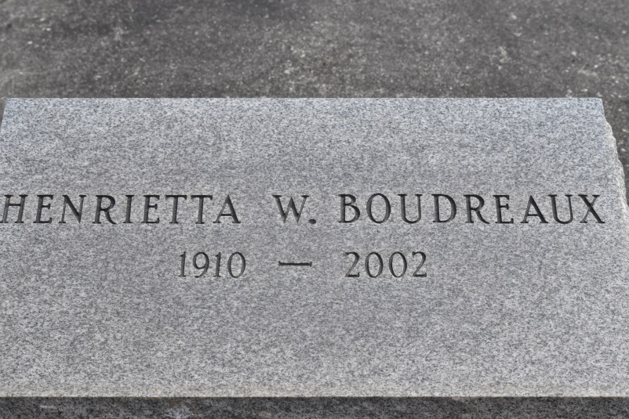

UNION - Henrietta Weber Boudreaux, 91, a native and resident of Union, died Jan. 14. She was the wife of the late Louis Boudreaux. She was the daughter of the late Henry and Estelle Sarazin Weber and sister of the late Philomene and Richard Weber. She is survived by nieces, nephews and cousins.

She was a retired insurance agent.

Services are today at noon at St. Mary Catholic Chapel, Union, with interment at the church cemetery. Visitation starts at 10 a.m.
L'Observateur (LaPlace, Louisiana) - Thursday, January 17, 2002
Contributed by Jane Edson

