Ann (Labat) Chauvin
September 19, 1919 – August 19, 2016

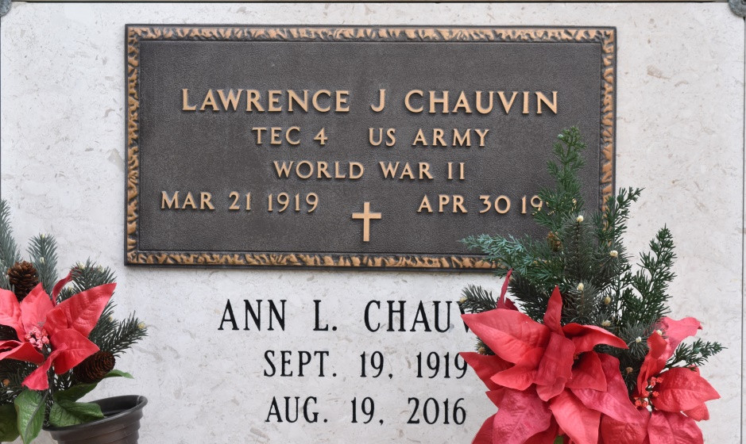

Ann Labat Chauvin was born in Vacherie, LA on September 19, 1919. She was a native of Convent, LA and a resident of Baton Rouge for the last 24 years. Preceded in death by Husband: Lawrence J. (Tut) Chauvin, Parents: Dasise J. Labat and Angelle Oubre Labat, 4 brothers.
Survived by Children: Carolyn (Warren) Richard of Marrero, LA, Jerry (Anna) Chauvin of Prairieville, LA, and Brenda (Mark) Gremillion of Baton Rouge, LA; 6 grandchildren: Warren Richard, Jr., Cindy Distefano, Melissa Sullivan, Chad Chauvin, Todd Chauvin, and Steven Gremillion; 5 great-grandchildren: Ellis Distefano, Jane Marie Sullivan, Caleb Chauvin, Amelia Chauvin, and Preston Chauvin; Sisters: Rose Mae Schexnayder, and Una Dugas both of Convent, LA.
The family would like to thank the entire staff at Landmark for their loving care and concern.
Visitation St. Michael Catholic Church, Convent, LA, Monday, August 22, 2016, 9:30 a.m. until 10:45 a.m. followed by a Mass of Christian Burial 11:00 a.m. Burial St. Mary's Cemetery, Union, LA. ROSE LYNN FUNERAL SERVICES, 1870 Cabanose Ave., Lutcher, LA is in charge of the arrangements. To sign and view the family guestbook, please visit www.roselynnfuneralhome.com.
Published in TheAdvocate.com
August 19 to August 22, 2016

