Ethel Constance (Jumonville) Chauvin
July 26, 1921 - July 10, 2005

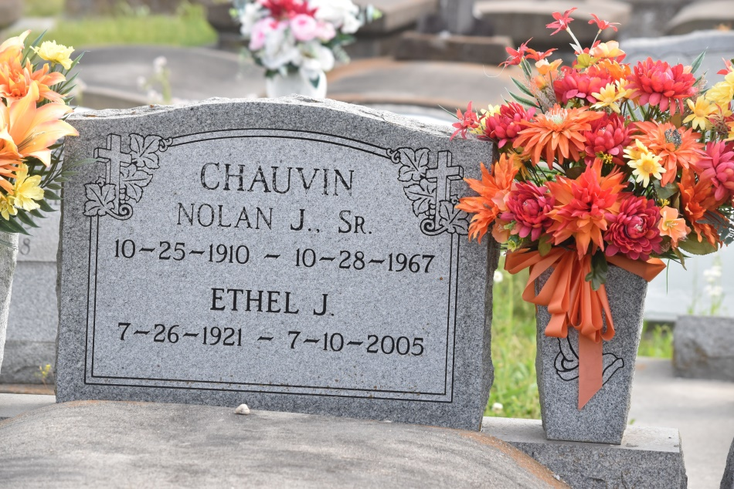

Ethel Chauvin - A homemaker and a resident of Gonzales, she died at 7:58 a.m. Sunday, July 10, 2005, in Gonzales. She was 83 and a native of Union. Visiting at Ourso Funeral Home, Gonzales, Tuesday, July 12, from 9 a.m. to 10:30 a.m. Mass of Christian Burial at St. Mary Catholic Church, Convent, at 11 a.m. Tuesday, with the Rev. Vic Panaligan, celebrant. Interment in St. Mary Cemetery, Convent.
She is survived by three daughters and two sons-in-law, Marie and Roger St. Pierre, Linda and Pete Decoteau, and Marilyn Chauvin, all of Gonzales; two sons and daughters-in-law, Alvin and Rowena Chauvin and Michael and Mary Chauvin, all of Gonzales; five sisters, Doris Waguespack, Gonzales, Marie Schexnayder, Burnside, Ida Roth, Harahan, Myrtle Bearb, Darrow, and Aray Templet, St. Amant; two brothers, Adolph Jumonville Jr., Holden, and Edward Jumonville, Gonzales; 14 grandchildren, three stepgrandchildren, 14 great-grandchildren and four stepgreat-grandchildren.
She was preceded in death by her husband, Nolan Chauvin Sr.; three sons, Nolan Jr., Perry and Jimmy; parents, Adolf and Louise Trabeaux Jumonville; and a brother, Dalton Jumonville.
Gonzales Weekly Citizen (Ascension Parish, LA) - Monday, July 18, 2005
Contributed by Jane Edson

