June Rose (Champton) Chauvin
June 7, 1938 - August 18, 2023

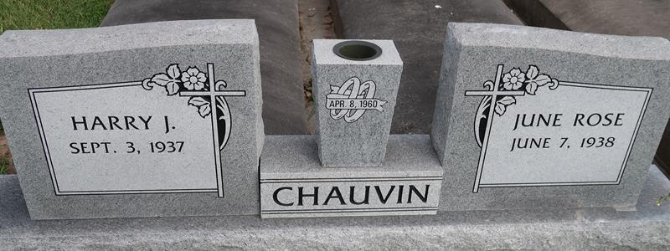

June Rose Champton Chauvin passed away on Friday, August 18, 2023 at the age of 85. She was born in Convent, LA and was a resident of Gramercy, LA. She enjoyed baking, cooking, gardening, sewing until she lost her eye sight which then led to her love to listen to audio books. She will be sadly missed by all who loved her as well as her stories that she loved sharing with her family.
Beloved wife of Harry Joseph Chauvin. Loving mother of Elizabeth Breaux, Eric Chauvin (Francis) and the late Craig Chauvin. Grandmother of Brandy Despino, Lindsey Breaux, Sydney Chauvin and Philip Chauvin. Great-grandmother of Jayden Despino and Wes Chauvin. Daughter of the late Mamie Mire Champton and Joseph Anthony Champton. Sister of Ronnie Champton and David Champton (Belinda). Also survived by nieces and nephews.
Relatives and friends are invited to attend the Visitation and Funeral Mass at St. Michael the Archangel Catholic Church, 6476 LA- 44, Convent, LA on Tuesday, August 22, 2023. Visitation at church from 9:00 a.m. to 11:00 a.m. followed by a Funeral Mass at 11:00 a.m. Interment in St. Mary Cemetery, Convent, LA.
Rose Lynn Funeral Home, Lutcher, Louisiana
August 21, 2023

