Marilyn Theresa Chauvin
June 26, 1955 – January 21, 2019

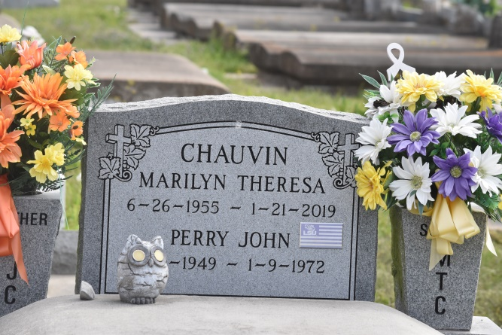

Marilyn Theresa Chauvin, native of Burnside and resident of Gonzales, passed away on Monday, January 21, 2019 in Gonzales. She was 63 years old. Marilyn was a Material Control Specialist with Triad Electrical.
Survived by her best friend and roommate, Gwen Blank and their daughter, Nevaeh Blank; 2 sisters and brothers-in-law, Linda and Pete Decoteau, Marie and Roger "Tilly" St. Pierre; 2 brothers and sisters-in-law, Alvin and Rowena Chauvin, Mike and Mary Chauvin, all of Gonzales; 3 godchildren, Neal Waguespack and spouse Paula, Chase Wise and spouse Cheyenne and Aubrie Madison LeCoq.
Preceded in death by her parents, Nolan Joseph Chauvin, Sr. and Ethel Constance Jumonville Chauvin; 3 brothers, Nolan "BB" Chauvin, Jr., Perry Chauvin, David "Jimmy" Chauvin; 1 godchild, Nathan Villeneurve.
Visitation will be held at Ourso Funeral Home in Gonzales on Thursday, January 24, 2019 from 6PM - 9PM and will resume at St. Mark Catholic Church on Friday, January 25, 2019 from 9AM until Mass of Christian Burial at 11AM, celebrated by Rev. Rubin Reynolds. Pallbearers will be Jason LeBlanc, Chris Clement, Travis Chauvin, Brandon Chauvin, Jamie St. Pierre, Madison LeCoq, Tyler LeCoq and Jeff St. Pierre.
The family would like to ask all who attend the life celebration to wear LSU purple and gold. Visit www.oursofh.com to leave words of condolences. Ourso Funeral Home of Gonzales in charge of arrangements.
dignitymemorial.com - December 17, 2020

