Neola Marie Chauvin
May 17, 1919 – February 4, 2000

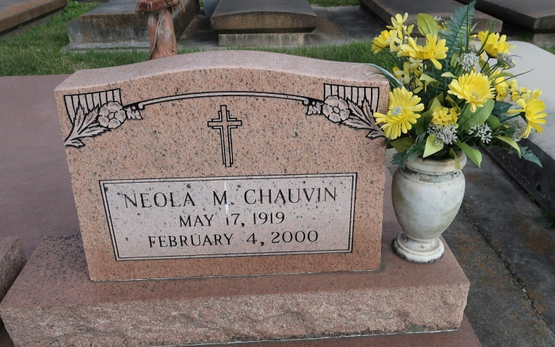

UNION - Neola Marie Chauvin, 80, a native of Union, died Feb. 4. She was the wife of the late Wilbert Chauvin and mother of Janice Stein, Adele Schexnaydre, Harry Chauvin and the late Larry Chauvin. She was also the sister of Tilda "Beek" Chauvin and the late June, Anna and Louis Chauvin. She is also survived by 11 grandchildren and 16 great-grandchildren.
She was preceded in death by three grandchildren.
Services were held Feb. 7 at St. Mary's Chapel, Union, with interment at St.Mary Cemetery.
L'Observateur (St. John the Baptist Parish, LA)
Wednesday, February 9, 2000
Contributed by Jane Edson

