Ophelia (Schexnayder) Chauvin
September 8, 1920 – February 26, 1992

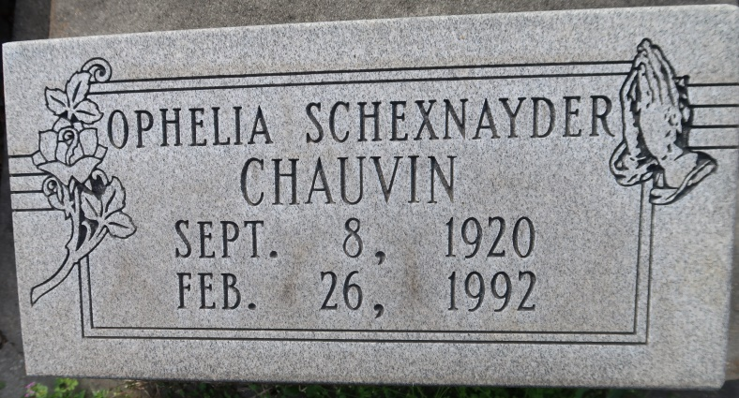

CHAUVIN, Ophelia Schexnayder "Loute"

Died Wednesday, Feb. 26, 1992, at Our Lady of the Lake Regional Medical Center. She was 71, a native and resident of Union. Visiting at St. Mary's Catholic Church, Union, 9:30 a.m. until religious services at 2 p.m. Thursday, conducted by Father Dick McGuinness. Burial in St. Mary's Cemetery.
Survived by a daughter, Peggy Stein, Gonzales; a son, Kenneth Chauvin, Gonzales; a daughter-in-law, Judy Chauvin, Gonzales; a son-in-law, Glenn Stein, Gonzales; three brothers, L.J. Schexnayder, Sorrento, Gary and Percy Schexnayder, both of Gonzales; four grandchildren, Neely Chauvin, Angie, Sheri, and Todd Stein.
Preceded in death by husband, Rene Chauvin; parents, Ernest and Lillian Louviere Schexnayder; a brother, Clarence Schexnayder; and a sister, Theresa Schexnayder.
She was a member of St. Mary's Altar Society.
Alexander Funeral Home, Lutcher, in charge of arrangements.
The Advocate (Baton Rouge, La.)
February 27, 1992 Page: 8-A

