Philip Chauvin, Jr.
September 30, 1927 – October 23, 2018

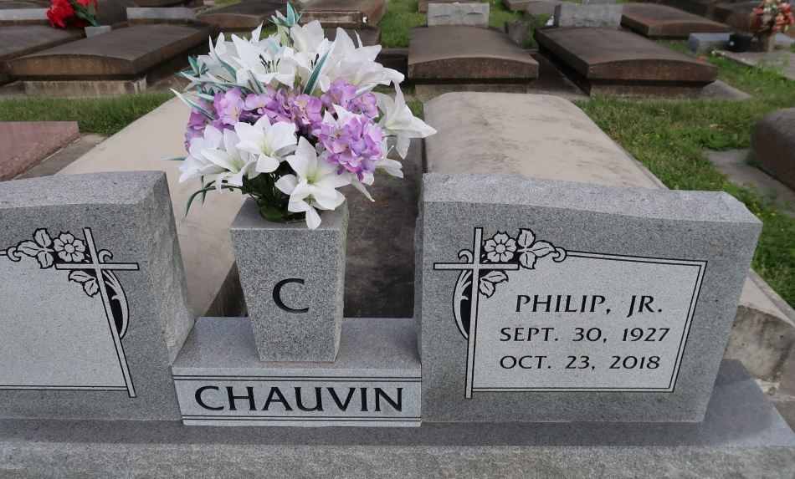

Philip Chauvin, Jr., a native of Union and resident of Gonzales, passed away Tuesday, October 23, 2018 at the age of 91. He was a loving husband of Tilda Ann Chauvin of 66 years. Devoted father of Belinda Champton and husband David Champton and Anita Waguespack and husband Gerald Waguespack. Grandfather of Pamela Burns and (Rocky), Leslie Champton, Philip Waguespack, Aaron Bateman and (Brian) and Gerri Bowler and (Tim). Great-grandfather of Rocky Jr, Zach and Hunter Burns, Jase and Stevie Lambert, Corin and Cara Waguespack, Brady and Brandt Bateman, Hudsyn and Hollyn Bowler. Loving brother of Gertrude Melancon and the late Wilbert Maurice, Andrew, Lynn, Adolf, Albert and Vivian Chauvin. He is preceded by his parents Philip Sr. and Aglae Chauvin.
Philip worked for Helvetia Sugar Mill and Kaiser Aluminum. He will be remembered for his love of camping, hunting and fishing. He was an avid LSU fan and never went anywhere without his LSU hat. He was dearly loved and will be missed by all who knew him.
Family and friends are invited to attend a visitation which will be held Thursday, October 25, 2018 at St. Theresa of Avila Catholic Church from 9:30 am - 11:30 am followed by a Mass of Christian Burial at 11:30 am. The burial will immediately follow in St. Mary Cemetery in Union. Pallbearers will be Philip Waguespack, Brian Bateman, Tim Bowler, Rocky Burns, Jase Lambert, Brady and Brandt Bateman.
The family would like to thank Brett Arceneaux, Amy Robertson and all the staff at Ascension Oaks Nursing Home for their compassion and care.
Please visit www.oursofh.com to leave expressions of sympathy and condolences. Ourso Funeral Home, Gonzales is in charge of arrangements.
dignitymemorial.com

