Rene Joseph Chauvin
October 25, 1914 – October 3, 1987

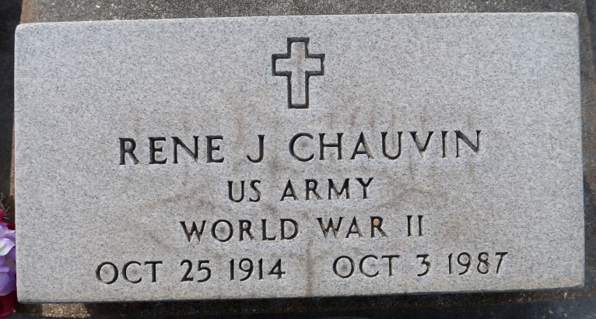

CHAUVIN, RENE JOSEPH

Died Saturday, Oct. 3, 1987, at his residence. He was 72, a native and resident of Union. He was a retired engineer with Helvetia Sugar Company.
Visiting at Alexander Funeral Home, Lutcher, 6 to 10 p.m. Sunday, and 8 to 10:15 a.m. Monday. Religious services at St. Mary Catholic Church, Union, at 11 a.m. Monday, conducted by the Rev. Dick McGuiness. Burial in church cemetery.
Survived by wife, Ophelia Schexnayder Chauvin, Union; a daughter, Peggy Stein, Gonzales; a son, Kenneth Chauvin, Gonzales; four grandchildren, Neely Chauvin, Angie, Cheri and Todd Stein; two sisters, Georgine Chauvin and Ursula Letulle; and two brothers, Lawrence and Harold Chauvin.
Preceded in death by parents, George and Jeanne Lanegrasse Chauvin; four brothers, George, Miller, Allen and J.C. Chauvin; and a sister, Virginia Melancon.
He was a member of American Legion Post No. 195.
The Advocate (Baton Rouge, La.)
October 4, 1987 Page: 8-B

