Stella (Jacob) Chauvin
January 8, 1913 – July 9, 2003

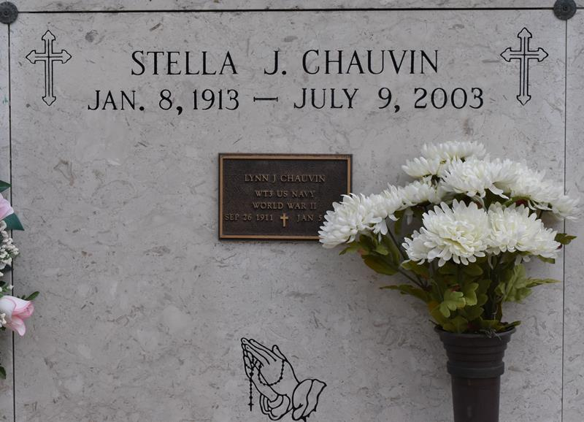

Stella Jacob Chauvin passed away at St. Elizabeth Hospital on Wednesday, July 9, 2003. She was 90 and a lifelong resident of Union. Mrs. Chauvin was a homemaker and a member of St. Mary's Altar Society.
She was the wife of the late Lynn Chauvin; and the daughter of the late Fernand and Celeste Landry Jacob. She was also preceded in death by her brothers and sisters. She is survived by numerous nieces and nephews.
Family and friends are invited to attend the funeral service. Mass of Christian Burial will be celebrated at St. Mary's Catholic Church, Union, at 11 a.m. Thursday. Entombment in church mausoleum. Visitation at the church from 9 a.m. to 10:50 a.m. Thursday. Arrangements under the direction of Alexander Funeral Home, 2208 Jefferson Highway, Lutcher, 225-896-5553.
Advocate, The (Baton Rouge, LA)
Thursday, July 10, 2003

