May Cecile (Barbier) Cox
November 9, 1905 – May 25, 2000

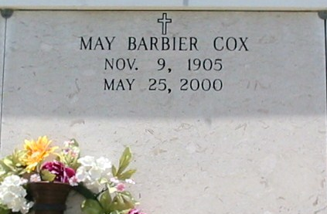
Photo by Bobby
Cecile May (Barbier) Cox - A devoted wife, mother and homemaker and a resident of Baton Rouge, she died at 7:45 a.m. Thursday, May 25, 2000, in Baton Rouge. She was 94, a native of Vacherie and a former resident of Convent. Visiting at St. Mary's Chapel, Union, from 9 a.m. Saturday until religious services at 11 a.m., conducted by the Rev. Mario Rizzuto. Entombment in church mausoleum. Survived by three daughters and two sons-in-law, Bertha Morel, Baton Rouge, Lucie and Charles Conrad, River Ridge, and Lorraine and ThomasMontero, Sanford, Fla.; a son and daughter-in-law, George Louis and Jo Ann Robert Cox, Convent; 14 grandchildren; and 23 great-grandchildren. Preceded in death by her husband, George Louis Cox; parents, Louis and Bertha Hymel Barbier; two sisters, Lucy and Thelma Barbier; two brothers, Henry and Albert Barbier; a great-grandson, Justin Cox; and a son-in-law, Ralph Morel. Pallbearers will be grandsons. She was a member of St. Michael Ladies Altar Society and Catholic Daughters of the Americas Court No.2080. Ourso Funeral Home, Gonzales, in charge of arrangements.

Advocate, The (Baton Rouge, LA)
Friday, May 26, 2000

