Morris John Cox
December 8, 1908 – June 17, 1953

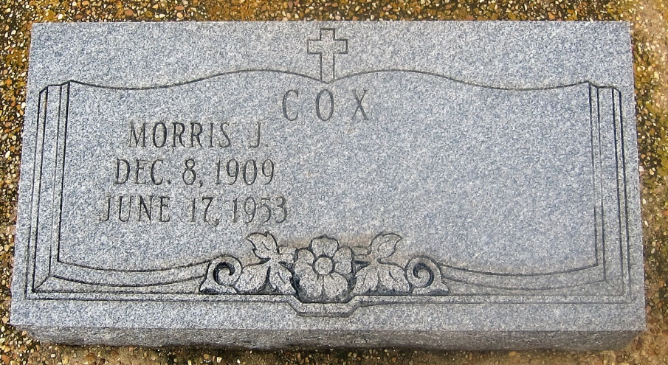
Photo by Bobby

There is an error on his tombstone. Was born 8 Dec 1908, baptized 17 Jan 1909
baptism sponsors - Thelesmar Mélançon & Léa Mélançon, née Letulle [SMU-2,127]
MORRIS J. COX
Life-long Central resident, died 5:30 p.m. Wednesday in Napoleonville. Survived by his wife, Mrs. Lowney Braud Cox, Gonzales; four sisters Mrs. Ora Harper, Hattiesburg, Miss.; Mrs. N. E. Mea Barrow, Jackson, Miss.; Mrs. Victoria Johnson, Miss Carrie Cox, both of Central; four brothers, George Cox, Central; Brent Cox, Pierre Part; Dr. Nelson Cox of Napoleonville, and Louis Cox of Donaldsonville. Funeral services to be conducted Friday morning, Landry-Montz in charge. Religious services to be conducted Friday morning at St. Mary's Chapel in Union. Interment in St. Mary's Catholic Cemetery. Officers, employees of the State National Life Insurance Co., where Cox was employed as an agent, and of the Welsh Funeral Home are in invited to attend the services.

Obituary - The Baton Rouge Advocate; 6/18/1953; Sec A, Pg 6, Col 1
Contributor: Jay Schexnaydre (jayschex@gmail.com)

