Rose Angela (Letulle) Cox
August 29, 1873 – December 1, 1947

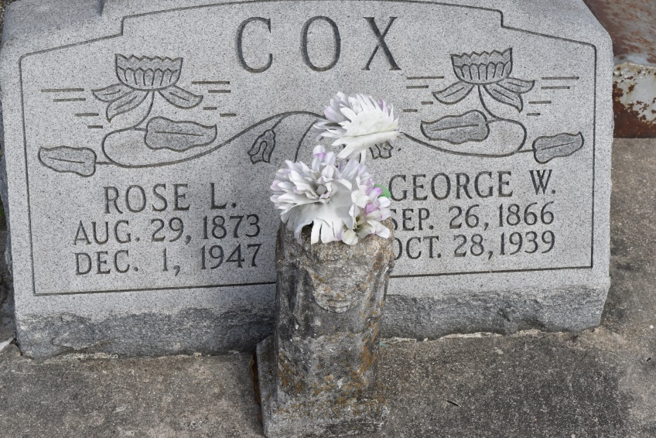

COX - of Central, La., on Monday, December 1, 1947, at 9 o'clock p.m., Rose Letulle, wife of the late George W. Cox, mother of Mrs. Ora Harper of Hattiesburg, Miss., Mrs. Nemea Barrow of Jackson, Miss., George Cox, Jr., Victoria Cox Mitchell, Carrie Cox and Morris Cox, all of Central, La., Brent J. Cox of Breaux Bridge, La., Dr. Nelson A. Cox of Napoleonville, La., and Lewis H. Cox of New Orleans, La., also survived by 16 grandchildren; aged 74 years 3 months 3 days.
Relatives and friends of the family are respectfully invited to attend the funeral, which will take place from the late residence, Central, La., on Wednesday morning, December 3, 1947, at 9 o'clock a.m., followed by requiem high mass at St. Mary Chapel. Interment in St. Mary Cemetery, Union, La.
Landry and Ourso Funeral Home of Donaldsonville, La., in charge.
The Time-Picayune (New Orleans, LA)
December 3, 1947, p. 2

