Albert J. Daigre, Sr.
November 16, 1946 – February 18, 2015

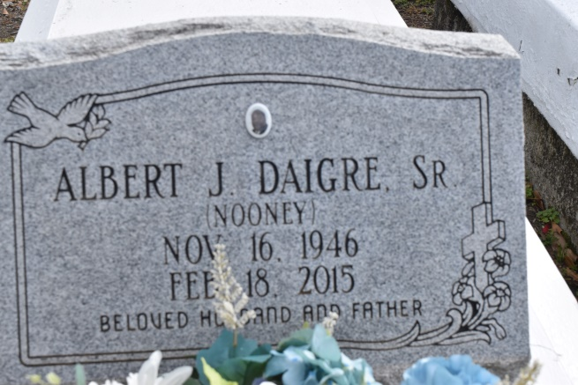

Albert (Nooney) Daigre Sr. Age 68, departed this life on Wednesday February 18, 2014, Son of the late Ethel Mae Burl Daigre and Welton Daigre. Husband of Carolyn J. Daigre. Father of Donnie (Yolanda), Albert Jr (Sharanique), Delwyn(Ebony), Michael (Mecca), Timothy Sr(Merqueldra), and Kimberly Daigre. Brother of Myrna T. Adams and Johnny Daigre Sr. Nephew of Huey P. Fleming Sr. and Albert (Red Bill) Burl. Also survived by 12 grandchildren, 2 Sisters in laws, 2 Brothers in laws, 3 godchildren and a host of others relatives and friends.
Services will be on Saturday February 28, 2014 at 10:00am at St. John B.C. 820 New Rafe Meyer Rd. Baton Rouge, La 70807 Dr. Donald Ruth hosting pastor and Rev. Keno M.L. Spurlock Officiating,. Interment in Philippian B.C. cemetery (sic), 10154 Burnside St., Convent, La. Visitation at the church from 9am until service time.
Services Entrusted to Hobson Brown Funeral Home, 134 Daisy St., Garyville, La 70051; 985-535-2516.
The Advocate (Baton Rouge, LA)
Feb. 26 to Feb. 28, 2015.

