Kimberly Ann Krischelle Daigre
September 15, 1986 – June 8, 2021

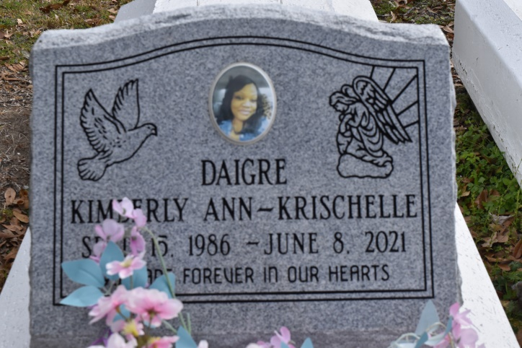

Kimberly Ann Krischelle Daigre was born on September 15, 1986, in Baton Rouge, LA to the union of Carolyn (Jasper) Daigre and the late Albert J. (Noonie) Daigre, Sr. Kimberly departed this life on Tuesday, June 8, 2021, at Our lady of the Lake Hospital in Baton Rouge, LA, at the age of 35.
Kimberly is the sister of Donnie (Yolanda), Delwyn (Ebony), Michael (Mecca), Albert Jr, (Sharanique) and Timothy Daigre Sr. Aunt of Brandon, Jaylen, Timothy, Jr., Michael II, Gorgi, Khaniah, Timia, Madison, Khamel, Bryson, Daylen, Daxton, Kiarra, and Epipthany Daigre. Kimberly is also survived by her devoted Aunts Shelia Hill, and Myrna Adams, 1 Uncle Kenneth Jasper (Barbara), 1 great Uncle Huey P. Fleming, 1 loved godson Braydon Hill, her loving Big-Lil Cuz Brandon (Danielle) and a host of other relatives and friends.
Celebration Service will be held on Wednesday June 16, 2021, at Immaculate Conception Catholic Church, 1565 Curtis St., Baton Rouge, LA. At 11am, Father Thomas Clark Host, Bishop Gregory Cooper, Sr., Pastor of Antioch Full Gospel Baptist Church, Officiating. Visitation will be Wednesday, June 16, 2021, at the Church from 9am-11am. Burial will follow at Philippian Baptist Church Cemetery, 10142 Burnside St., Convent, LA 70723. Due to CDC (covid19) restrictions seating is limited, mask and social distancing are required.
Professional Services entrusted to the Caring Staff of Hobson Brown Funeral Home, 134 Daisy St. Garyville, La 70051, 985-535-2516.
The Advocate (Baton Rouge, LA)
June 14 to June 16, 2021.

