Katherine A. Darville
March 31, 1939 – February 16, 2018

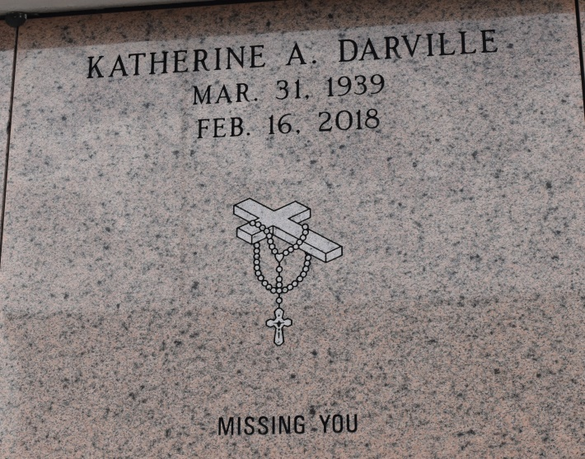

A native of Convent and a resident of New Orleans. She passed away at Canon Hospice in Jefferson at 1:15 p.m., Friday, February 16, 2018. She was 78. Visiting at St. Michael's Catholic Church in Convent, Saturday, February 24, 2018 from 9:00 a.m. until Mass of Christian Burial at 11:00 a.m., conducted by the Rev. Vincent Dufresne. Recitation of the rosary at 9:30 a.m. St Mary's Catholic Church Mausoleum.
Survived by her devoted cousin, Perry (Doris) Gaudin. Her devoted friends: Geralyn Facine, Minnie Reese, Rose Sceau and Wanda Richard. Her godchildren, Carmen Benn Johnson, Nichelle Gaudin Webster and Conrad Benn, other relatives and friends.
Preceded in death by her parents: Wilbert Darville and Irma Benn. Her brother: Andrew Thompson. Her maternal grandparents: Johnny and Leontine Stewart and her uncles, Andrew and Oliver Benn.
BRAZIER-WATSON FUNERAL HOME IN CHARGE OF ARRANGEMENTS. Visit us at www.brazierwatson.com to sign our guest book.
The New Orleans Advocate (LA)
Feb. 22 to Feb. 24, 2018.

