Albertine (Melancon) Delmore
January 18, 1921 – December 15, 2000

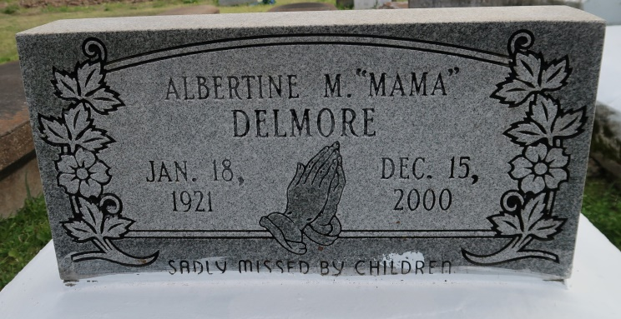

Albertine Delmore, 79 - Born Jan. 18, 1921, to Armond Jefferson Melancon Sr. and Carrie Picou Melancon, she departed this life at 5:45 a.m. Friday, Dec. 15, 2000, at Our Lady of the Lake Regional Medical Center, Baton Rouge. She was baptized and confirmed at St. Mary's Catholic Church, Convent. Visitation was at Hambrick's Family Mortuary, Gonzales, from 6 p.m. to 9 p.m. Friday, with recitation of the rosary at 7 p.m. Visiting at St. Mary's Catholic Church, Convent, from 10 a.m. until Mass of Christian Burial at 11 a.m. Saturday, celebrated by the Rev. Mariano Rizzuto. Interment in St. Mary's Cemetery.
She leaves to cherish her precious memory four daughters, Mabel Washington, Gonzales, Carolyn Clayton, Sheila Scott and Terri Delmore, all of Convent; three sons, Alvin Delmore and Lester Delmore Jr., both of Baton Rouge, and Lee Charles Delmore, Lutcher; three daughters-in-law; two sons-in-law; 39 grandchildren, including Robin Williams, Convent, whom she reared; 40 great-grandchildren; three great-great-grandchildren; a foster great-great-grandchild, Rainey Tamar Davis; eight sisters-in-law, Everlena Melancon, Reserve, Ruth, Emma, Ethel, Mary and Dorothy Delmore and Pearl Nabor, all of Gonzales, and Helen Delmore, New Orleans; three brothers-in-law, Freddie Delmore, Prairieville, John Delmore Jr., Gonzales, and Lennis Delmore, Austin, Texas; best friend, Margaret Tureaud; and numerous nieces, nephews, other relatives and friends.
Preceded in death by her husband, Lester Delmore Sr.; parents, three daughters, a son, five grandchildren, a sister and two brothers.
Advocate, The (Baton Rouge, LA)
Saturday, December 23, 2000
Contributed by Jane Edson

