Alvin Delmore, Sr.
July 13, 1941 – March 6, 2012

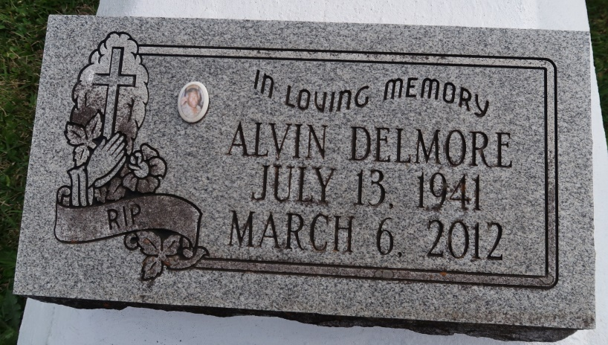

Alvin Delmore Sr. - A resident of Baton Rouge and native of Convent, he departed this life on Tuesday, March 6, 2012, at Baton Rouge General Medical-Mid City. He was 70.
Visiting at Hambrick's Family Mortuary, Gonzales, on Friday, March 9, from 5 p.m. to 8 p.m., and on Saturday, March 10, from 10 a.m. until religious service time at noon at St. Mary Catholic Church in Convent, LA.
He is survived by his relatives and friends.
Please sign the guestbook at www.hambricksfm.com.
Advocate, The (Baton Rouge, LA)
Friday, March 9, 2012
Contributed by Jane Edson

