Mary Alice Joy (Rusha) Dornier
July 5, 1930 – July 17, 2010

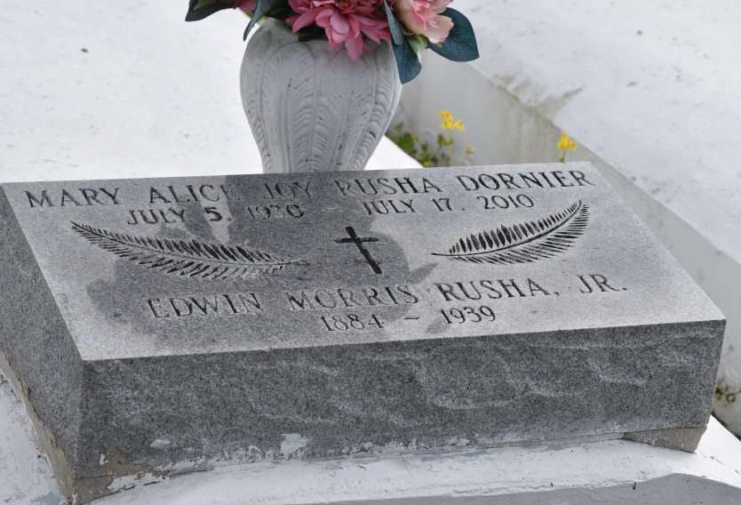

Mary Alice Joy (Rusha) Dornier
A resident of Convent, born July 5, 1930, in New Orleans, she passed away Saturday, July 17, 2010. She was 80. Visiting at St. Michael the Archangel Catholic Church, Convent, Tuesday, July 20, from 9:30 a.m. until Mass of Christian Burial at 11 a.m., with recitation of the rosary at 10 a.m. Burial in St. Mary Church Cemetery, Union.
She is survived by a daughter, Natalie Dornier Hawthorne and husband Donald; son, Keith Dornier and wife Christine; brother, Morris Rusha; eight grandchildren and three great-grandchildren.
Preceded in death by her husband, Raymond Dornier Sr.; parents, Edwin Morris Rusha and Marguerite Webre Rusha; son, Raymond Dornier Jr.; daughter, Brenda Dornier Black; and granddaughter, Kirby Lea Hawthorne.
Arrangements by Ourso Funeral Home, Gonzales, www.oursofh.com.
Advocate, The (Baton Rouge, LA)
Monday, July 19, 2010
Contributed by Jane Edson

