Clement Andrew Dupepe
August 25, 1925 – January 20, 2004

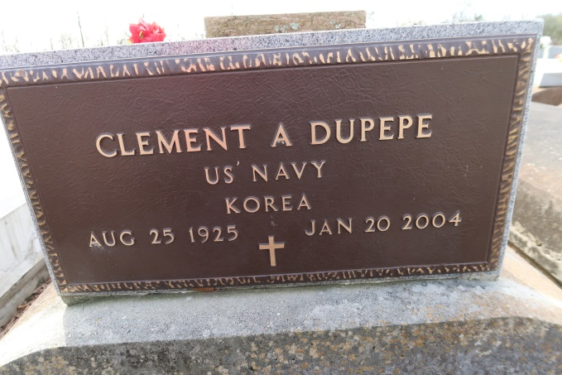

DUPEPE, CLEMENT ANDREW
BeBe led a quiet and simple life with a loving and giving spirit. He passed from this earth, but not from our hearts. Clement Andrew Dupepe, 78, a native and resident of Union, died Tuesday, Jan. 20, 2004, at St. Elizabeth Hospital, Gonzales. He was born on Aug. 25, 1925.
BeBe is survived by two sisters, Rosalie Dupepe Porta of Azalea Estates in Gonzales and Shirley Dupepe Louviere Durabb of Norco; a half-sister, Shirley B. Young of Baton Rouge; nieces, Karen Chauvin Bergeron of St. Amant, Joan Dupepe Bergeron, Susan Dupepe Boudreaux and Julie Porta Gautreau, all of Gonzales; and nephews, Lionel V. Porta Jr. and Mark Dupepe of Gonzales, Lynn Louviere and John Louviere of Norco.
Preceded in death by his parents, Fernand G. Dupepe Sr. and Julie Mire Dupepe; sisters, Lillian Dupepe Chauvin, Barbara Dupepe and Mercedes Dupepe, who were all of Union; and a brother, Fernand G. Dupepe Jr., a niece, Sherry Dupepe Bourgeois, a nephew, Michael Paul Dupepe, and a great-niece, Pamela Ann Gautreau, who were all of Gonzales.
Visitation at St. Mary's Chapel in Convent from 9 a.m. until Mass of Christian Burial at 11 a.m. Thursday, Jan. 22, 2004, celebrated by the Rev. Ed Fuss. Burial in church cemetery. He was a member of Hymel's Coffee Club.
In lieu of flowers, donations may be made in his name to Alzheimer's Services of the Capital Area, 2041 Silverside Drive, Baton Rouge, LA 70808.
Ourso Funeral Home, Gonzales, in charge of arrangements.
Advocate, The (Baton Rouge, LA)
Thursday, January 22, 2004
Contributed by Jane Edson

