Lucille (Abadie) Dupepe
March 6, 1922 – July 19, 2005

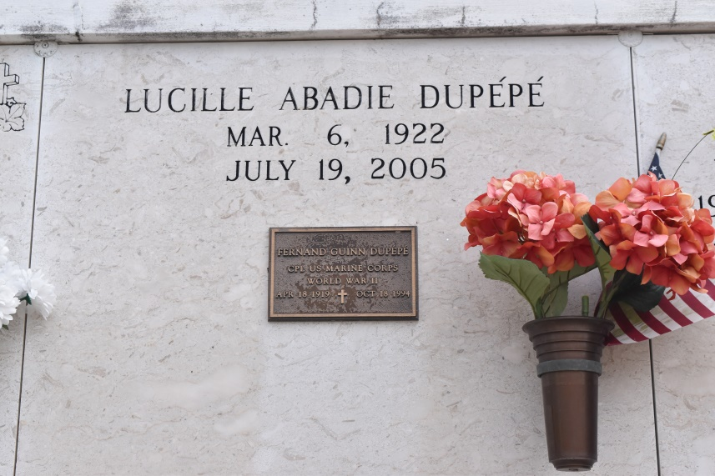

Lucille Abadie Dupepe
A retired laboratory technician with Helvetia Sugar Mill, she died at 4:20 a.m. Tuesday, July 19, 2005, in Baton Rouge. She was 83, a resident of Gonzales and a native of Wallace. Interment in St. Mary's Chapel, Union.
She is survived by two daughters and sons-in-law, Joan and Lynn Bergeron and Susan and Bubby Boudreaux, both of Gonzales; son and daughter-in-law, Mark and Janet Dupepe of Gonzales; son-in-law, James Bourgeois of Gonzales; three sisters, Grace Pitre, Dolly Louviere and Clara Boudoin, all of Houma; three brothers, Clifford, Melvin and Errol Abadie, all of Houma; and 12 grandchildren and 15 great-grandchildren.
She was preceded in death by her parents, Simeon Raymond and Aurore Waguespack Abadie; husband, Fernand Guinn Dupepe; daughter, Sherry Bourgeois; son, Michael Dupepe; brother, June Abadie; and three sisters, Mercedes Cooper, Carmen McDonald and Aurora Dickerson. Pallbearers were her grandsons.
Gonzales Weekly Citizen (Ascension, LA)
Monday, August 1, 2005
Contributed by Jane Edson

