Odile E. Folse
November 27, 1906 – September 6, 2002

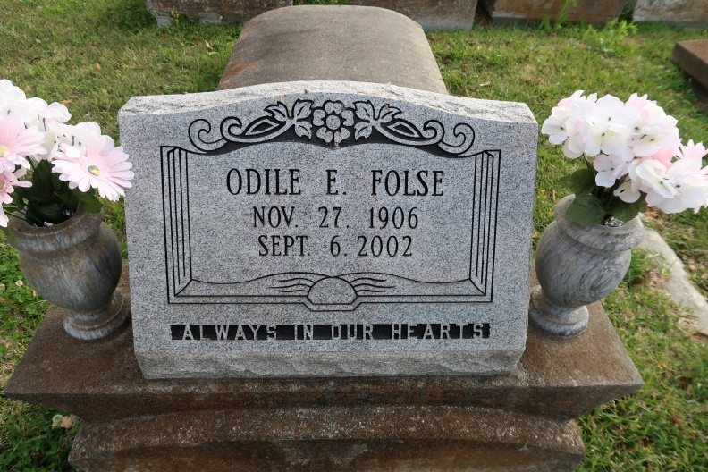

Odile E. Folse
A beloved sister and aunt and a resident of Darrow, she died Friday, Sept. 6, 2002, at Our Lady of the Lake Regional Medical Center, Baton Rouge, after a brief illness. She was 95 and a native of Eagle Lake, Texas. Interment in St. Mary Cemetery, Union.
Survived by two sisters, Leah LeBoeuf, St. James, and Dorothy Bajoie, Baton Rouge; a sister-in-law, Vivian Folse, St. James; a brother-in-law, August Bajoie, Baton Rouge; numerous nieces, nephews, other relatives and friends.
Preceded in death by her parents, Joseph and Marie Folse; three brothers, Benny, Joseph and Nathan Folse; and three sisters, Justine Burbank, Janie LeDuff and Katherine LeDuff.
Gonzales Weekly Citizen (Ascension, LA)
Wednesday, September 11, 2002
Contributed by Jane Edson

