Leroy Camille Frederic
September 10, 1927 – July 19, 2001

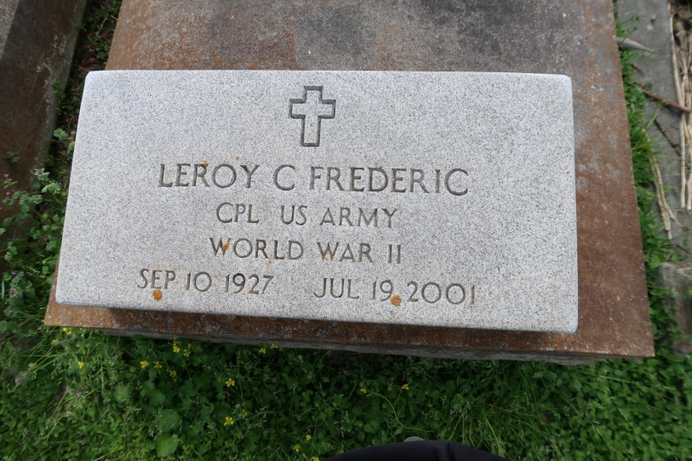

Camille Leroy Frederic, a retired operator for Ormet Corp., died Thursday of heart failure at Our Lady of the Lake Hospital. He was 73. Mr. Frederic was a lifelong resident of Convent. He served in the Army during World War II and was stationed in Japan.
Survivors include his wife, Yvette Mire Frederic; a son, Patrick Frederic; a daughter, Gwen F. Schexnayder; a sister, Marjorie Goubert; two grandchildren; and two great-grandchildren.
A Mass will be said today at 10 a.m. at St. Mary Catholic Church, River Road, Convent. Visitation will begin at 8 a.m. Burial will be in St. Mary Catholic Church Cemetery. H.C. Alexander Funeral Home is in charge of arrangements.
Times-Picayune, The (New Orleans, LA)
Monday, July 23, 2001
Contributed by Jane Edson
**

CONVENT - Camille Leroy Frederic, 73, a native and resident of Convent, died July 19. He was the husband of Yvette Mire Frederic and father of Gwen Schexnayder and Patrick Frederic. He was the brother of Marjorie Goubert. He is also survived by two grandchildren and two great-grandchildren. Services were July 23 at St. Mary Catholic Church, Convent, with interment at the church cemetery.
L’Observateur, LaPlace, Louisiana
July 25, 2001

